
Study Instructions and Core Reading

Pointe Du Hoc, Normandy
(6 to 8 June 1944)
Virtual Staff Ride

- Study Instructions 2

- Core Reading 5
  - Background 5
  - The Cliff Assault 9
  - The Landing 11
  - The Cliff Assault 14
  - Capture the Pointe 24
  - Advance to the Highway 31
  - Morning at the Pointe: Action on the Left Flank 37
  - Morning at the Pointe: The CP Group 40
  - Afternoon Counterattacks 45
  - The Advance Group During D-Day 48
  - The German Night Attack: First Phase 51
  - The Night Attack: Second Phase 57
  - The Night Attack: Finale 59
  - The Relief Effort: 7 June 63
  - The Relief Effort: 8 June 65

- Appendix A: The Germans at Pointe Du Hoc 68
- Appendix B: LTC James Rudder and the Ranger Task Organization. 72
- Appendix C: Ranger Organization in the Strongpoint Area. 75
- Appendix D: Ranger Organization in along the Coastal Highway 76
- Appendix E: Naval Support at Pointe Du Hoc 78

Pointe Du Hoc, 6 to 8 June 1944: This 2 hour virtual staff ride is one of the five staff ride modules for the Normandy Virtual Staff Ride.

- This material is designed to assist in preparing for the virtual staff ride. The readings provide context for the operation and give the participants the details of the operations that will be covered during the virtual staff ride. It is highly recommended that participants read all the assigned material.

- The staff ride is not a lecture; it is a facilitated discussion. The better prepared the participants are, the better the staff ride will go.

All participants must read and study:
- The Core Reading: Pointe Du Hoc (2D Ranger Battalion, 6 - 8 June 1944)

- One of the supplemental readings as noted in the assignments below.

Each staff ride participant should be assigned and study one of the below assignments:
- The Combat Studies Institute recommends each staff ride participant be assigned specific unit to research and discuss during the field study phase. More than likely there are more participants than assignments and it is recommended that you assign small groups to each of the assignments.

- The mini-experts on particular subtopics will discuss the actions and decisions from both their own and their assigned focus. They should be prepared to discuss:

- Unit organization and equipment, training, and morale.
- Key decisions, why those decision were made, and the consequence of the decision.
- Unit’s actions and accomplishments.

Assignments:

  - Assignment #1 – The Germans at Pointe du Hoc: This assignment will focus on the following:
    - 9/3/726 Infantry and 2/1260 Artillery at the Strong Point
    - Additional elements of the 3/726 Infantry and 1/914 Infantry that participated in the counterattack against the Pointe.

    - Read the Core Reading: The Core Reading: Pointe Du Hoc (2D Ranger Battalion, 6 - 8 June 1944)

    - Read Appendix A: The Germans at Pointe Du Hoc

  - Assignment #2: LTC James Rudder: This assignment will focus on LTC Rudder’s decisions and the consequences of those decisions.

    - Read the Core Reading: The Core Reading: Pointe Du Hoc (2D Ranger Battalion, 6 - 8 June 1944)

    - Read Appendix B: Notes on LTC James Rudder and the Ranger Task Organization.
    - Biographies are readily available with an internet search. Highly recommend - The First Night on Pointe du Hoc: An Excerpt from Thomas M. Hatfield's Rudder: From Leader to Legend at https://www.humanitiestexas.org/news/articles/first-night

  - Assignment #3: 2d Ranger Battalion (The Strongpoint Rangers): The Ranger Battalion consisted of 3 small companies. Other than the cliff assault, the Rangers at Pointe du Hoc did not operate as companies. They instead operated with about ½ the battalion on the coastal highway and the other ½ fighting to secure the strongpoint area. Both groups contained elements of all 3 companies. The groups were separated by about 600m and were not mutually supporting. This assignment focuses on the Rangers fighting at the strongpoint.

    - Along with Coastal Highway Rangers (Assignment #4) discuss the landing, assault, initial attempts to clear the strongpoint. Focus primarily on D Co. (LCAs 858 & 668- 1st Sgt Lomell).
    - Then focus on:
      - The German counterattacks against the strongpoint area.
      - The efforts to secure the strongpoint until relieved by advancing elements of the 116th Infantry.

    - Read the Core Reading: The Core Reading: Pointe Du Hoc (2D Ranger Battalion, 6 - 8 June 1944

    - Read Appendix B: Notes on LTC James Rudder and the Ranger Task Organization

    - Read Appendix C: Ranger Organization in the Strongpoint Area.

  - Assignment #4: 2d Ranger Battalion (The Coastal Highway Rangers): The Ranger Battalion consisted of 3 small companies. Other than the cliff assault, the Rangers did not operate as companies. They instead operated with about ½ the battalion on the coastal highway and the other ½ fighting to secure the strongpoint area. Both groups contained elements of all 3 companies. The groups were separated by about 600m and were not mutually supporting. This assignment focuses on the Rangers fighting on the coastal highway.

    - Along with Strong Point Rangers (Assignment #3) discuss the landing, assault and initial attempts to clear the strongpoint. Focus primarily on E Company (LCAs 722, 888, 862, 861) and F Company (LCA’s 883, 884, and 887 – Sgt Petty).
    - Then focus on the
      - The Movement to and day time actions at the coastal highway.
      - The nighttime battle for the coastal highway.

    - Read the Core Reading: The Core Reading: Pointe Du Hoc (2D Ranger Battalion, 6 - 8 June 1944)

    - Read Appendix B: Ranger Task Organization.

    - Read Appendix D: Ranger Organization in along the Coastal Highway

  - Assignment #5 – Naval Support and the USMC at Pointe du Hoc: This assignment will focus on the naval support for the Rangers at Pointe du Hoc.

    - Read the Core Reading: The Core Reading: Pointe Du Hoc (2D Ranger Battalion, 6 - 8 June 1944)

    - Read Appendix E: Naval Support at Pointe Du Hoc

Core Reading
POINTE DU HOC
2d RANGER BATTALION
6 -8 June 1944
Excerpt from CMH PUB 100-14. Small Unit Actions, Pointe de Hoc, 1-63. Note: originally titled Pointe Du Hoe in the 1982 printing.
Background
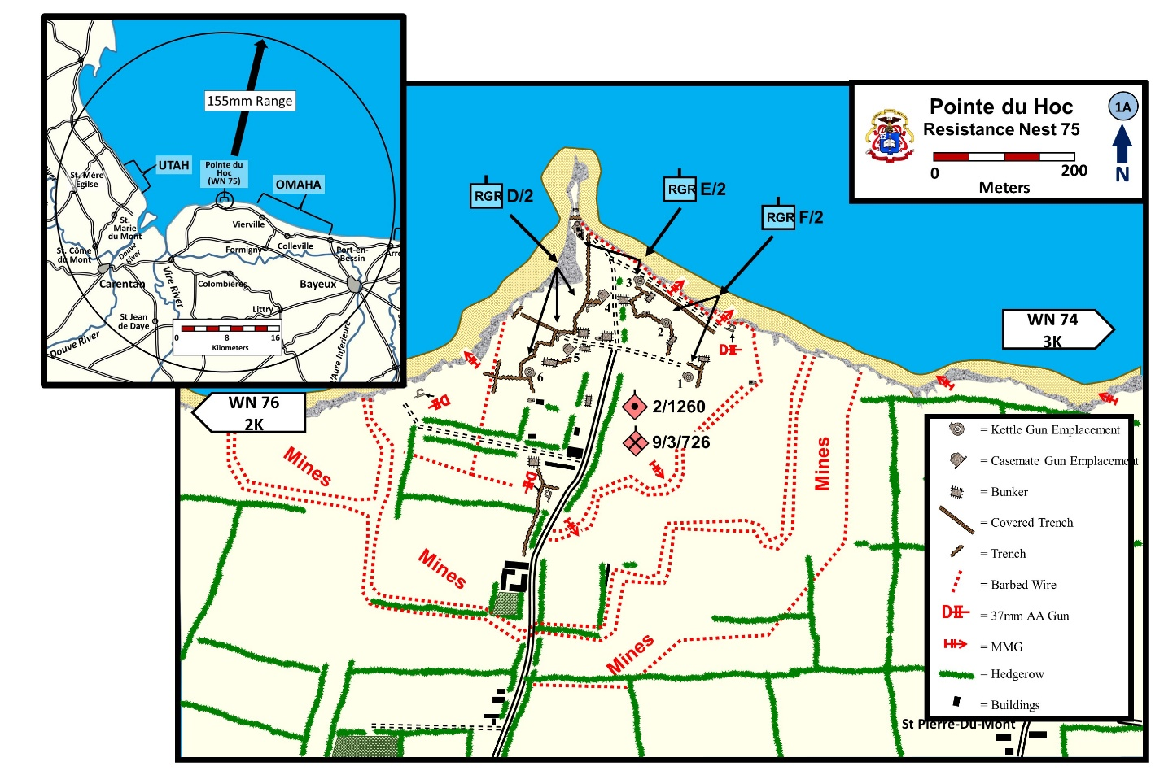
On 6 June 1944 the V Corps of U.S. First Army assaulted German coastal defenses on a 6,000-yard stretch ("Omaha" Beach) between Vierville and Colleville. Their aim was to establish, on D Day, a beachhead three to four miles deep extending from the Drôme River to the vicinity of Isigny. The attack was made by two divisions, the 1st and 29th, with strong attachments of armor and artillery. On their right flank, a separate mission of unusual difficulty was assigned to a special assault force.
At Pointe du Hoc, four miles west of Omaha Beach, the Germans had constructed a fortified position for a coastal battery of six 155-mm howitzers of French make; four guns were in open emplacements and two were casemated, with further construction work on casemates reported under way in April and May. This battery was [believed to be] one of the most dangerous elements in the German coastal defenses of the assault area. With a 25,000-yard range, the 155's could put fire on the approaches to Omaha Beach and on the transport area of V Corps; in addition they could reach the transport area from which VII Corps, to the west, would unload for assault at the base of the Cotentin Peninsula ("Utah" Beach).
The position at Pointe du Hoc was strongly protected from attack by sea. Between Grandcamp and the Omaha sector, the flat Norman tableland terminates abruptly in rocky cliffs. At Pointe du Hoc, these are 85 to 100 feet high, sheer to overhanging; below them is a narrow strip of beach, without the slightest cover for assaulting troops. Aerial photographs indicated what was later confirmed by French civilians: that the enemy regarded the position as nearly impregnable from seaward attack and were more concerned with defending it against an enemy coming from inland. The battery was part of a self-contained fortress area, mined and wired on the landward side. Its flanks were protected by supporting positions mounting machine guns and antiaircraft guns. These positions were sited to put enfilade fire on the beaches under the Point, and to aid its defense against any inland attack. Enemy troops at Pointe du Hoc were estimated at 125 infantry and 85 artillerymen, included in the sector of enemy coastal defenses, from the Vire to the Orne, held by the 716th Infantry Division. This unit contained a high percentage of non-German troops, and was regarded as of limited fighting value. Elements of the 726th Infantry Regiment held the sector from Vierville to Grandcamp, in which, because of the continuous stretch of cliffs, coastal strongpoints were widely spaced. Those nearest Pointe du Hoc were one mile distant on the west and two miles to the east. The Germans -had made no preparations to defend this part of the coast in depth. The 716th Division was stretched thinly along 30 miles of shore; behind it, but believed 10 to 12 hours away, the 352d Infantry Division in the St-Lô-Caumont area was the nearest mobile reserve.
The Ranger Group, attached to the 116th Infantry and commanded by Lt. Col. James E. Rudder, was given the mission of capturing Pointe du Hoc and neutralizing the dangerous German coastal battery. The Group was made up of two battalions: the 2d Rangers, under direct command of Colonel Rudder, and the 5th Rangers, under Lt. Col. Max F. Schneider. Three companies (D, E, and F) of the 2d Battalion were to land from the sea at H Hour and assault the cliff position at Pointe du Hoc. The main Ranger force (5th Battalion and Companies A and B of the 2d) would wait off shore for signal of success, then land at the Point. The Ranger Group would then move inland, cut the coastal highway connecting Grandcamp and Vierville, and await the arrival of the 116th Infantry from Vierville before pushing west toward Grandcamp and Maisy.
- The plan called for LTC James Rudder to command the Ranger Group from the Command Ship USS ANCON.

  - The ANCON was the CP for: Admiral Hall (Commander of the O Force) General Gerow (5th Corps), General Huebner (1st Infantry Division) and General Hoge (1st Special Engineer Brigade).

  - On the night of 5 June, Rudder relieved Major Cleveland Lytle, the commander of Force A, because of a drunken brawl and his lack of faith in the feasibility of the mission. Then Rudder took direct command of Force A.

- Both LTG Bradley (US 1st Army) and LTG Huebner reluctantly approved the last minute change. There was concern that no one was now overlooking the activities of the Ranger Group.

Zaloga, Steven, Ranges Lead the Way, 25-26.
An alternate plan was ready if the support force of Rangers had not received word, by H+30, of success in the attack on the cliffs at Pointe du Hoc. In this event, the larger Ranger force would land on the western end of Omaha Beach (Vierville sector) behind the 116th Infantry and proceed overland toward the Pointe, avoiding all unnecessary action en route to its objective.
Company C, 2d Rangers, had a separate mission of its own at Omaha Beach. It was ordered to land with the first assault wave of the 116th and knock out German strongpoints near Pointe de la Percée, immediately flanking the Omaha landing beaches.
Special attention was given the Pointe du Hoc battery in the preparatory air and naval bombardments. As early as 15 April, medium bombers of the Ninth Air Force had begun attacks to soften up the position and to slow enemy efforts to construct further casemates. In order not to tip off the invasion plans, these early attacks could not be made too often and were combined with wide-ranging missions directed at other points on the French coast from Brittany to Belgium. On 22 May and 4 June, Ninth Air Force bombers struck again and on the night of 5/6 June RAF heavies included the Point in a major attack on batteries along the whole invasion coast. Naval bombardment of the Omaha sector and its flanks began at 0550 on 6 June; particular attention, especially by the main batteries of the battleship Texas (14-inch guns), was paid to Pointe du Hoc in this fire. At H-20 minutes (0610), 18 medium bombers of the Ninth Air Force made a last strike on the Point.
TIP OF POINTE DU HOC. Photo taken from east side (1945).
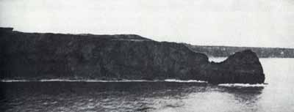
At H Hour, 0630, the three companies of the 2d Rangers, led by Colonel Rudder, were scheduled to touch down at the foot of the cliffs and deliver their assault. They totaled about 225 men, including a headquarters detachment.
- Unknown to Allied intelligence, the 25 April raid (40 tons) had been accurate and devastating.
  - Two of the open “kettle” emplacements were destroyed.
  - One gun damaged beyond repair.
  - Two guns rendered inoperable.
  - The bunkers proved their worth - only 2 KIA and 3 WIA.

- The allies were also unaware that the Germans moved the guns to an alternate position about 1.3K south of the Pointe.

- French resistance had passed the information that the guns had been moved to an alternate position. However, Allied aerial reconnaissance believed the guns to be still at the Pointe. The Germans had positioned camouflaged wooden guns at the Pointe positions to mislead Allied aerial reconnaissance.

Black, Robert. The Battalion, 69-70.

Assault Plans
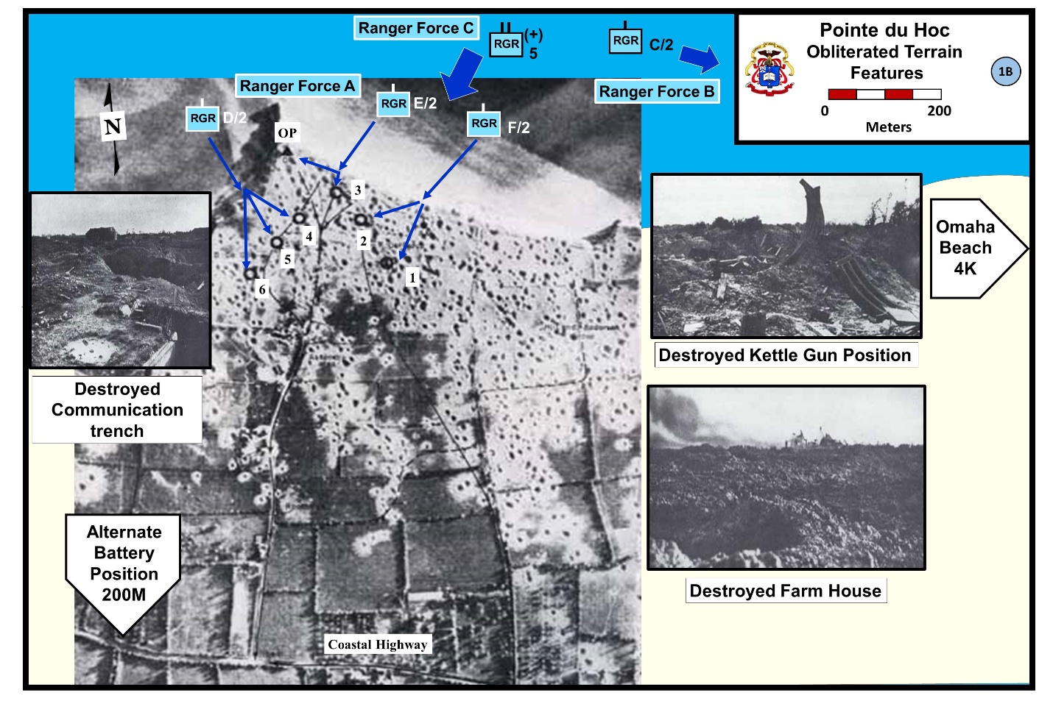
The three companies selected for the mission at Pointe du Hoc had received intensive training and had developed special equipment for the operation. During April and May, at Swanage on the Isle of Wight, the personnel had been conditioned by hard practice in rope and ladder work on cliff s like those of the French coast, combined with landing exercises in difficult waters. Personnel of British Commando units gave all possible help, based on their experience in coastal raids. As a result of experiment with all types of equipment for escalade, main reliance was placed on ropes to be carried over the cliff tops by rockets; in addition, the assault wave would take along extension ladders. British landing craft (LCA's) with British crews were used both in the training and in the actual operation.
Ten LCA's would be sufficient to boat the three small Ranger companies and headquarters party, including signal and medical personnel, with an average of 21-22 men on a craft. Each LCA was fitted with three pairs of rocket mounts, at bow, amidship, and stern, wired so that they could be fired in series of pairs from one control point at the stern. Plain ¾ -inch ropes were carried by one pair of rockets, affixed to the rocket's base by a connecting wire. A second pair was rigged for rope of the same size fitted with toggles, small wooden crossbars a few inches long inserted at about one-foot intervals (see illustration, page 13) ; the third pair of rockets was attached to light rope ladders with rungs every two feet. The rockets were headed by grapnels. The rope or ladder for each rocket was coiled in a box directly behind the rocket mount. Each craft carried, in addition to the six mounted rockets, a pair of small, hand-projector-type rockets attached to plain ropes. These could be easily carried ashore if necessary.
Extension ladders were of two types. One, carried by each LCA, consisted of 112 feet of tubular-steel, 4-foot sections weighing 4 pounds each; these ladders were partly assembled in advance in 16-foot lengths. For mounting the whole ladder in escalade work, a man would climb to the top of a length, haul up and attach the next 16-foot section, and repeat this process until the necessary height was reached. As a final auxiliary for climbing, four dukws would come in close behind the first wave, each carrying a 100-foot extension ladder, fire-department type, with three folding sections. Two Lewis machine guns were mounted at the top of each of these ladders, which would be particularly useful for getting up supplies.
Speed was essential for this operation, and the small assault force was equipped for shock action of limited duration, with a minimum load of supplies and weapons. Dressed in fatigue uniform, each Ranger carried a D-bar for rations, two grenades, and his weapon, normally the M-1 rifle. A few of the men selected for going first up the ropes carried pistols or carbines. Heavier weapons were limited to four BAR's and two light mortars per company. Ten thermite grenades, for demolition, were distributed within each company. Two supply boats (LCA's) would come in a few minutes after the assault wave, with packs, extra rations and ammunition, two 81 -mm mortars, demolitions, and equipment for hauling supplies up the cliff.
The tactical plan provided for Companies E and F to assault on the east side of the Point, and Company D on the west (Map 1B, page 6). On reaching the cliff top, each boat team had a series of specific objectives, beginning with the gun emplacements and other fortifications on the Point. With these first objectives taken, most of the force was to push out immediately to the south, reach the coastal highway which was a main communications lateral for German defenses of the Grandcamp-Vierville coast, and hold a position controlling that road to the west until the arrival of the 116th Infantry from Vierville. If the assault at Omaha went according to schedule, the 116th would be at Pointe du Hoc before noon. Long before then, the main body of Rangers (eight companies) should have followed in at the Point to strengthen the foothold won by the initial assault.
As a final feature of the plans, fire support after the landing would be available on call from supporting naval craft and from artillery landing after 0800 near Vierville. A Naval Shore Fire Control Party (12 men) and a forward observer of the 58th Armored Field Artillery Battalion were attached to Colonel Rudder's headquarters, which was distributed among the four LCA's carrying Company E.

The Landing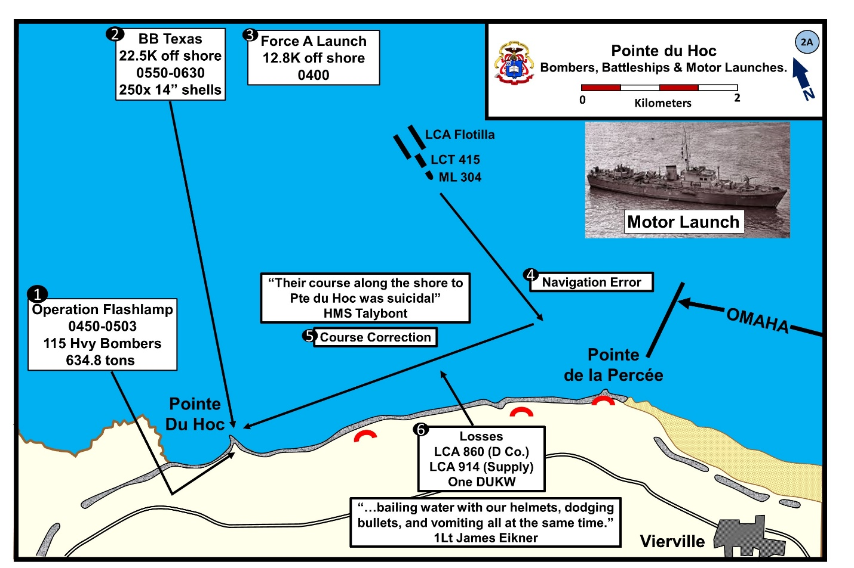
D-Day weather was unfavorable for a landing assault, with rough seas that imperiled small landing craft during their approach to the beaches. Early visibility along the coast was poor, and an eastward-setting tidal current helped to produce errors in navigation. The results, on the Omaha Beach sectors, were delays in reaching shore and enough mislanding of assault craft to interfere seriously with the early schedule for the attack. The Ranger force did not escape these difficulties.
Shortly after leaving their transports (the LSI's Ben Machree and Amsterdam), the craft began to suffer from the results of the heavy going. LCA 860, carrying Capt. Harold K. Slater and 20 men of Company D, swamped in the 4-foot choppy waves. The personnel were picked up by rescue craft and carried to England, eventually to rejoin their unit on D+ 19. Ten minutes later one of the supply craft sank, with only one survivor. The other supply craft was soon in trouble and had to jettison all the packs of Companies D and E in order to stay afloat. The other craft survived, with varying degrees of trouble; several shipped so much water that the men had to ball with their helmets to help the pumps. From the start, all the Rangers were soaked with spray. In one respect they enjoyed exceptional luck: there were very few cases of seasickness, in contrast to the general record at Omaha. Despite being wet, cold, and cramped by the three-hour trip, personnel of the three Ranger companies reached the shore in good shape for immediate and strenuous action. The most serious effect of the wetting was to soak the climbing ropes and rope ladders, making them heavier.
- Concurrent with the fires, Ranger Force A launched at 0400 for the 2 ½ hour trip for the almost 13K approach to the beach.

- The Royal Navy Motor Launch (ML) 304 was responsible for leading the Force A flotilla to the Pointe.

- From almost the start of the operation, the Rangers encountered a number of unforeseen events. Unfortunately, the navigation system on ML 304 failed. This combined with the rough seas, strong current, and darkness resulted in the ML leading the Rangers toward Pointe de la Percée, about 5k east of their objective.

- About 0630, when daylight revealed the shoreline at about 1000M, LTC Rudder realized the navigation error and took the lead in his LCA.

  - At first the British crews of the LCAs were reluctant to change course – their orders were to follow ML 304. Getting the Army ashore was a Navy Responsibility. No Army officer had authority to overrule the commander of ML 304.

  - The change in course required the flotilla to hug the coast line back to Pointe Du Hoc against a gauntlet of fire.

  - The commander of the destroyer Talybont remembered, “Their course… along the shore to Pte. du Hoc was suicidal.

Black, Robert. The Battalion, 94. Ambrose, Stephen. D-Day, 406
The leading group of nine surviving LCA's kept good formation, in a double column ready to fan out as they neared shore. Unfortunately, the guide craft lost its bearings as the coast line came in sight, and headed straight for Pointe de la Percée, three miles east of the target. When Colonel Rudder, in the lead LCA, realized the error he intervened and turned the column westward. But the damage had been done. The mistake cost more than 30 minutes in reaching Pointe du Hoc; instead of landing at H Hour, the first Ranger craft touched down about H+38, a delay that determined the whole course of action at the Point for the next two days. The main Ranger flotilla, eight companies strong, was following in from the transports, watching anxiously for the signal of success at Pointe du Hoc (two successive flares shot by 60-mm mortars). By 0700, if no message or signal had come, Colonel Schneider's force was scheduled to adopt the alternate plan of action and land at the Vierville beach. They waited ten minutes beyond the time limit and then received by radio the code word TILT, prearranged signal to follow the alternative plan. So Colonel Schneider turned in toward Vierville, where the 5th Rangers and A and B of the 2d landed at 0745. Pending the outcome at Omaha Beach, and the success of Colonel Schneider's force in fighting cross country to the Point, Colonel Rudder's three companies would fight alone.

The error in direction had further consequences. The correction headed Colonel Rudder's column of LCA's back toward Pointe du Hoc, but now on a westerly course, roughly paralleling the cliffs and only a few hundred yards offshore. The flotilla thus had to run the gauntlet of fire from German strongpoints along three miles of coast. Fortunately these were few, and their fire was wild and intermittent. The only serious casualty was a dukw, hit by 20-mm fire as it neared the target area. Five of the nine men aboard were killed or wounded.
The plan for landings had to be changed as a result of the misdirected approach. Since the column of LCA's was now coming at the Point from east instead of north, Company D's craft would not be able to swing out of column and reach the west side of the promontory in time to assault with the other units. Therefore, to effect synchronized attack, the nine assault craft deployed and came in on line together at the east side.
A final result of the delay was apparent as they reached the goal. Naval fire had halted just before H Hour, and the enemy on Pointe du Hoc had 40 minutes to recover from the effects of the bombardment. As the LCA's neared the Point, they received scattered small-arms and automatic fire, and enemy troops were observed moving near the edge of the cliff. There was, however, no indication of artillery in action from the enemy positions.
At 0710, as the first craft were grounding under the cliffs, radio silence was broken to send Colonel Schneider the order for landing at Vierville. The message was acknowledged. The small assault force was not entirely alone as it came in to a hostile shore. The British destroyer Talybont, which had taken part in the early bombardment of Pointe du Hoc at range of 2.7 miles, saw the flotilla heading in on a wrong course, and found it difficult to understand, "as Texas' fall of shot on Pointe du Hoc was obvious." As the Rangers corrected course and came under fire from the cliff positions, the Talybont closed range and for 15 minutes (0645-0700) raked enemy firing positions with 4-inch and 2-pounder shells. Meantime, the U.S. destroyer Satterlee, 2,500 yards from Pointe du Hoc, could see enemy troops assembling on the cliff, and opened with main battery and machine-gun fire.
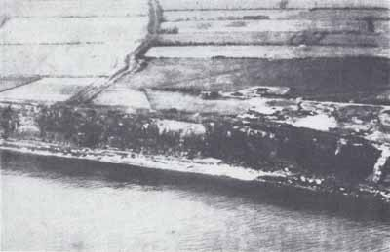
WESTERN HALF OF FORTIFIED AREA, photographed in February 1943 by aerial reconnaissance. The farm lane inland is the route followed by Company F group to reach the highway on D Day
The Cliff Assault
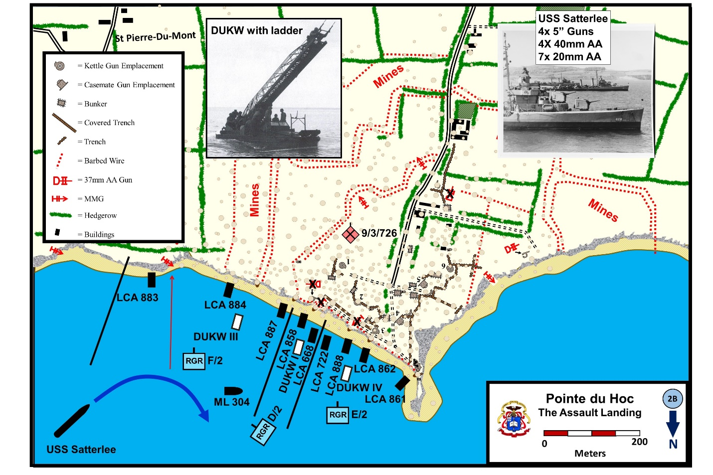
(Note: North is at the bottom of Map 2B)
The nine LCA's touched down on a front of about 500 yards, the right-hand craft just under the tip of Pointe du Hoc, and the others spaced fairly evenly. No great distance separated some -of the boat teams, but according to plan they went into action as separate units, each facing its particular problems of escalade and opposition.
Royal Navy Lt. Beever (ML 304), despite his navigation challenges, was no coward and took his wooden ML close inshore and fired 20 rounds from his small main gun and over 1,000 20mm rounds.

Black, Robert, The Battalion, 102
In certain general respects, their problems were similar. The 30-yard strip of beach between water and cliff had been completely cratered by bombs. The craters were to handicap the unloading of men and supplies and were to render the dukws useless after landing, for these craft were nowhere able to cross the sand and get close enough to the cliff to reach it with their extension ladders. The cliff face showed extensive marks of the naval and air bombardment; huge chunks of the top had been torn out, forming talus mounds at the base. A few grenades were thrown down or rolled over the edge as the first Rangers crossed the sand, and enemy small-arms fire came from scattered points along the cliff edge. Particularly dangerous was enfilade fire, including automatic weapons, from the German position on the left flank of the beach. Once at the foot of the cliff the Rangers were better off, for the piles of debris gave partial defilade from the flanking fires, and the enemy directly above would have to expose themselves in order to place observed fire or to aim their grenades.

.
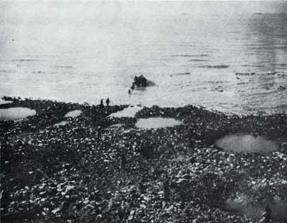
BOMB AND SHELL HOLES in the narrow strip of rocky beach, at the foot of the cliffs, slowed the Rangers in getting to the shelter of the cliffs after landing. This photo, taken on D+1, shows a boatbringing in first supplies for the beleaguered Rangers.
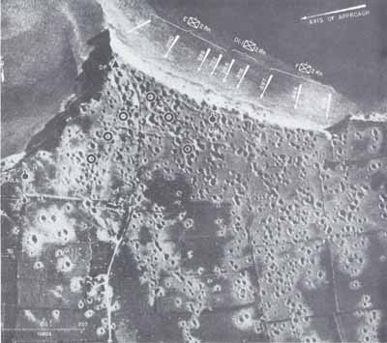
The Assault Landings at Pointe du Hoc
Naval support came to the aid of the Rangers at this critical moment. The destroyer Satterlee watched the craft reach shore, and saw the enemy firing from the cliff above.
The Satterlee immediately took the cliff tops under fire from its 5-inch guns and 40-mm machine guns. Fire control was excellent, despite attempts of enemy machine guns and a heavier gun to counter the destroyer's effort. Comdr. J. W. Marshall, commanding the Satterlee, believed this fire was decisive in enabling the Rangers to get up the cliff. However, his impression that the assault force "was pinned under the cliff and being rapidly cut to pieces by enemy fire" is not confirmed by the speed with which the escalade got under way, or by other details of the landing. Curiously enough, only three or four men out of 120 survivors interviewed remembered noticing naval fire after touchdown. One of these was Colonel Rudder, who "had the living hell scared out of him" by explosions which brought down a section of cliff just over his head, and which came from an unknown source. Both impressions—the Rangers', that there was no fire support worth mentioning, and the Satterlee's, that the Rangers were pinned down—are easily understandable under the circumstances of battle and the difficulties of observation. The probability is that the destroyer's fire on the cliff top, at the moment when the Rangers were starting their assault, did a great deal to prevent effective enemy opposition at the decisive moment.
In any event, the assault went forward without check. Ranger casualties on the beach totaled about 15, most of them from the raking fire to their left. In something less than ten minutes from landing, the first Ranger parties were getting over the cratered edges of the cliff top. The story of the boat teams will be given in order from right to left, roughly the order of landing.
LCA 861. Carrying a boat team of Company E, commanded by 1st Lt. Theodore E. Lapres, Jr., this craft grounded about 25 yards from the bottom of the cliff. Three or four Germans were standing on the cliff edge, shooting down at the craft. Rangers near the stern took these enemy under fire and drove them out of sight. At the instant of touchdown the rear pair of rockets was fired, then the other two pairs in succession. All the ropes fell short of the cliff edge, as a result of being thoroughly soaked. In some cases not more than half the length of rope or ladder was lifted from the containing box.
As the Rangers crossed the strip of cratered sand, grenades were thrown down from above them, or rolled over the cliff edge. These were of the "potato-masher" type, with heavy concussion effects but small fragmentation. They caused two casualties. The hand-rockets were carried ashore, and the first one was fired at 15 yards from the cliff. It went over the top and caught. Pfc. Harry W. Roberts started up the hand-line, bracing his feet against the 80-degree slope. He made about 25 feet; the rope slipped or was cut, and Roberts slithered down. The second rocket was fired and the grapnel caught. Roberts went up again, made the top (he estimated his climbing time at 40 seconds), and pulled into a small cratered niche just under the edge. As he arrived, the rope was cut. Roberts tied it to a picket. This pulled out under the weight of the next man, and the rope fell off the cliff, marooning Roberts. However, a 20-foot mound of clay knocked off the cliff enabled Roberts' team to get far enough up the side to throw him a rope. This time he lay across it, and five men, including Lieutenant Lapres, came up. Roberts had not yet seen an enemy and had not been under fire. Without waiting for further arrivals, the six Rangers started for their objective, the heavily constructed OP at the north tip of the fortified area. About ten minutes had elapsed since touchdown.
Just after Lapres' group got up, a heavy explosion occurred above the rest of 861's team, waiting their turn on the rope. Pfc. Paul L. Medeiros was half buried under debris from the cliff. None of the men knew what caused the explosion, whether a naval shell, or the detonation of a German mine of a peculiar type found later at one or two places along the cliff edge. The enemy had hung naval shells (200-mm or larger) over the edge, attached by wire to a pull-type firing device and fitted with a short-delay time fuze. The explosion had no effect on the escalade. Medeiros and four more Rangers came up quickly, found Roberts' party already gone and out of sight, and followed from the cliff edge toward the same objective.
LCA 862. This craft, carrying 15 Rangers and NSFC personnel, landed about 100 yards left of the flank LCA. The men had no trouble in disembarking, but once on the sand they found themselves exposed to machine-gun fire from eastward of the landing area. One man was killed and one wounded by this fire; two more injured by grenade fragments.
The forward pair of rockets had been fired immediately on touchdown, followed by all four others together. One plain and two toggle ropes reached the top, but one toggle rope pulled out. Tech. 5 Victor J. Aguzzi, 1st Lt. Joseph E. Leagans (commanding the team), and S/Sgt. Joseph J. Cleaves went up the two remaining ropes, arrived at the top almost together, and fell into a convenient shell hole just beyond the edge. There they paused only long enough for two more men to join; then, following standard Ranger tactics, the five moved off without waiting for the rest of the team, who came up a few minutes later.
LCA 888. Colonel Rudder's craft, first to hit the beach, had 15 men of Company E and 6 headquarters personnel, including Lt. J. W. Eikner, communications officer. A few enemy troops were seen on the cliff edge as the LCA neared shore, but, when Sgt. Dominick B. Boggetto shot one German off the edge with a BAR, the others disappeared. The Rangers had trouble in getting through the beach craters; neck deep in water, they found it hard to climb out because of the slick clay bottom. A few grenades came over the cliff without causing casualties.
The rockets were fired in series, at 35 yards from the cliff base. None of the waterlogged ropes reached the top. When two Rangers, best of the group at free-climbing, tried to work up the smashed cliff face without ropes, they were balked by the slippery clay surface, which gave way too easily to permit knife-holds. Bombs or shells had brought down a mass of wet clay from the cliff top, forming a mound 35 to 40 feet high against the cliff. A 16-foot section of the extension ladder, with a toggle rope attached, was carried to the top of the mound and set up. A Ranger climbed the ladder, cut a foothold in the cliff, and stood in this to hold the ladder while a second man climbed it for another 16 feet. The top man repeated the process, and this time Tech. 5 George J. Putzek reached the edge. Lying flat, with the ladder on his arms, he held on while a man below climbed the toggle rope, then the ladder.

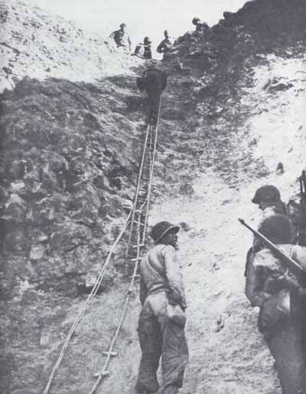
LAST LAP OF THE CLIMB. This may be the area where the men from LCA 888 managed to get up by use of an extension ladder, placed on a great mound of debris knocked out of cliff top. This photo was probably taken on D+2, when route was being used for supplies. A toggle rope and two plain ropes are seen below ladder.
From there on it was easy. As the first men up moved a few yards from the cliff edge to protect the climbers, they found plenty of cover in bomb craters, and no sign of an enemy. In 15 minutes from landing, all the Company E men from LCA 888 were up and ready to move on. Colonel Rudder and headquarters personnel remained for the moment below, finding shelter from enfilade fire in a shallow cave at the bottom of the cliff. By 0725, 1st Lt. James W. Eikner had his equipment set up and flashed word by SCR 300 that Colonel Rudder's force had landed. Five minutes later he sent out the code word indicating "men up the cliff"; the "Roger" that receipted for this message, again on SCR 300, was Eikner's last communication of D Day on the Ranger command net. When he sent the message PRAISE THE LORD ("all men up cliff") at 0745, no response was forthcoming.
LCA 722. Twenty yards left of Colonel Rudder's craft, LCA 722 hit shore with 15 Company E Rangers, 5 headquarters men, a Stars and Stripes photographer, and a Commando officer who had assisted the Rangers in training. Touchdown was made at the edge of a crater, and the men could not avoid it in debarking. Enemy grenades were ineffectual, and the craters and debris on the beach gave sufficient cover from enfilading fire from the left. The only casualty was Pfc. John J. Sillman, wounded three times as the craft came in, hit twice on the beach, and destined to survive. A good deal of assorted equipment came on this craft, including the SCR 284, two pigeons, a 60-mm mortar with ammunition, and some demolitions. All were got ashore without loss, though it took maneuvering to avoid the deep water in the crater. Tech. 4 C. S. Parker and two other communications men hefted the big radio set on a pack board, and managed to get it in and working before the first climbers from 722 reached the top.
The rockets had been fired just before landing. One ladder and one plain rope got up and held (LCA 722 had experienced no trouble with water, and the ropes were comparatively dry). The single rope lay in a slight crevice, but the ladder came down on an overhang where it seemed exposed to the flanking fire and would be hard to climb. Tech. 5 Edward P. Smith tried the plain rope and found he could easily "walk it up." On top three or four minutes after landing, he saw a group of Germans to his right throwing grenades over the cliff. Sgt. Hayward A. Robey joined Smith with a BAR. Robey lay in a shallow niche at the cliff edge and sprayed the grenadiers with 40 or 50 rounds, fast fire. Three of the enemy dropped and the rest disappeared into shelters. Pfc. Frank H. Peterson, lightly wounded on the beach by a grenade, joined up and the three Rangers went off on their mission without waiting for the next climbers.
The mortar section in this boat team remained below, according to plan, with the purpose of setting up their 60-mm on the beach to deliver supporting fires. But the beach was too exposed to make this practicable, and time was consumed in getting ammunition from the one surviving supply craft. About 0745 the mortar team went on top without having yet fired.
LCA 668. Company D's craft had been scheduled to land on the west side of the Point. As a result of the change in angle of approach, the two surviving LCA's came in to the left of Company E, and in the center of the Ranger line.
LCA 668 grounded short of the beach strip, as a result of boulders knocked from the cliff by bombardment. The men had to swim in about 20 feet. While 1st Sgt. Leonard G. Lomell was bringing in a box of rope and a hand-projector rocket, he was wounded in the side by a machine-gun bullet but reached shore and kept going. Despite the unusual distance from the cliff, and the very wet ropes, three rockets had carried the cliff edge with a toggle rope and the two rope ladders. However, the grapnels on the ladders just made the top; since the lead rope connecting grapnels with the top of the ladders was 40 feet long, the Rangers had, in effect, two plain ropes and a toggle. Sergeant Lomell put his best climber on the toggle while he tried one of the ladders. All ropes were on an overhang, and only the toggle line proved practicable. Even on it, climbing would be slow, so Lomell called for the extension ladders. Picking a spot high on the talus, his men found that one 16-foot section added to a 20-foot section reached the top of the vertical stretch, beyond which a slide of debris had reduced the slope enough to make it negotiable without ropes. Two men had got up by the toggle rope; the rest used the ladder and made the top quickly. Grenades caused some annoyance until the first men up could cover the rest of the party. Twelve men moved off from the edge with Sergeant Lomell and 1st Lt. George F. Kerchner.
LCA 858. Shipping enough water all the way in to keep the Rangers busy, this craft nevertheless kept up fairly well and was only a minute or two behind the others at the beach. The men were put out into a crater and went over their heads in muddy water. Despite the wetting, a bazooka was the only piece of equipment put out of action. Three men were hit by machine-gun fire from the east flank.
The rockets were fired in series, the plain ropes first. All the ropes were wet, and only one hand-line got over the cliff. It lay in a crevice that would give some protection from enemy flanking fire, but the direct approach to the foot of the rope was exposed. The Company D Rangers worked their way to the rope through the piles of debris at the cliff base. While one man helped the wounded get to Colonel Rudder's CP, where the medics had set up, all the party went up this one rope and found it not too hard going. They could get footholds in the cliff face, and a big crater reduced the steepness of the climb near the top. The group was up within 15 minutes. As in most other cases, the first few men on top had moved off together, and the boat team did not operate as a unit after the escalade.
LCA 887. As a result of Company D's unscheduled landing in the center of the line of craft, the three LCA's carrying Company F were crowded eastward, all of them touching down beyond the area originally assigned them. Few of the Rangers realized this at the time.
LCA 887 had not been much bothered by either water or enemy action on the trip in. The craft grounded five yards out from dry beach, and the shorter men got a ducking in the inevitable crater. No equipment trouble resulted; even Sgt. William L. Petty's BAR, wet here and muddied later when he slipped on the cliff, fired perfectly when first needed. Some enemy fire, including automatic weapons, came from either flank. Two Rangers were wounded.
Just before hitting the beach the two forward rockets were fired. Only one of the plain lines carried, and 1st Lt. Robert C. Arman, commanding the team, figured the heavier ropes had no chance. So, all four of the mounted rockets, together with the boxes carrying toggle ropes and ladders, were taken out on the sand-a matter of ten minutes' heavy work, while the coxswain of the LCA did a notable job of holding the craft in at the beach edge. When the rockets were set up for firing, the lead wire for making the firing connection was missing. Tech/Sgt. John I. Cripps fired all four in turn by touching the short connection, three feet from the rocket base, with his "hot-box." Each time, the flashback blinded Cripps and blew sand and mud all over him. The other Rangers saw him clean his eyes, shake his head, and go after the next rocket: "he was the hell-of-a-looking mess." But all the ropes went up, and made it possible for the party to make the top. Sergeant Petty and some other expert climbers had already tried the plain rope and failed; it was on a straight fall, requiring hand-over-hand work with no footholds possible, and the men had trouble with their muddy hands and clothes on the wet rope.
Sergeant Petty started up one of the ladders, got 30 feet up, and then slid all the way back on the cliff face when the grapnel pulled out. Tech. 5 Carl Winsch was going up the other ladder when fire from somewhere on the flanks began to chip the cliff all around him. Petty went up after Winsch, and found him, unwounded, in a shell hole at the top. Here Petty waited for two more Rangers and then they set out for their objective.
Sgt. William L. Petty, nicked named L-Rod, fell into a water-filled crater and ruined all of his hoarded tobacco. L-Rod started up one of the ropes, got 10M up, and then slid back. At the bottom the BN Surgeon, Cpt Walter Block, yelled at L-Rod to quit fooling around and get up the rope. L-Rod yelled back, “Go the hell captain…what does it look like I’m trying to do? You do your damn job and I’ll do mine.” Later that morning, L-Rod apologized to the doctor. It was said, “…not a good policy for a combat man to out of favor with the battalion surgeon.”
O’Donnell, Patrick. Dog Company, 68 & Black, Robert. The Battalion,108.
LCA 884. This craft, the target for considerable enemy fire from cliff positions on the way to the Point, had replied with its Lewis guns and the BAR's of the Rangers. Touchdown was made on the edge of a shell hole, in water shoulder-high. Three Rangers were hit by fire coining from the left flank. When rockets were fired in series, front to rear, four got over the cliff, but every rope lay in such position as to be fully exposed to the continuing enemy small-arms fire. Moreover, the Rangers were so muddled in getting through the craters on the beach that the plain ropes would have been unusable after the first climber went up. The only rope ladder that reached the top was caught below on beach boulders and hung at an awkward angle. Several men tried the other ropes without success, and Pvt. William E. Anderson got only part way up in his attempt at free-climbing. 1st Lt. Jacob J. Hill finally took the group over to the left, where they used the ladders of 883's boat team.
LCA 883. Last in the column of approach, this craft was last to reach shore, nearly 300 yards left of its planned position and considerably beyond the edge of the main fortified area on Pointe du Hoc. Just to their left, a jut in the cliff protected the boat team from the flanking fire that caused so much trouble for the other landing parties. They made a dry landing, and had a perfect score with the six rockets. This gave an opportunity to use the climbing assignments on a full schedule, using every rope. Nevertheless the going was hard, even on the ladders. 1st Lt. Richard A. Wintz, on a plain rope, found it impossible to get any footholds on the slippery cliff. The wet and muddy rope made it difficult for hand-over-hand pulling, and at the top Wintz was "never so tired in his life." He found six men together and started them out immediately.

CRATERED GROUND hampered the Rangers in moving cross country through the fortified area, and made it difficult to spot enemy snipers. This photo, looking inland, was probably taken on D+1.
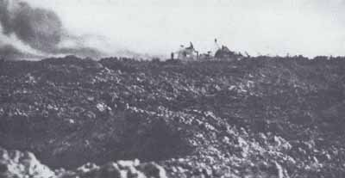
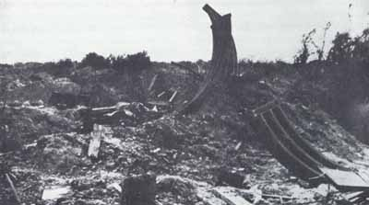
WRECKED EMPLACEMENTS on the Point. Photo taken June 1944.
Summary. The first great difficulty, landing and getting up the cliff, had been surmounted. Enemy resistance, despite the delayed landing, had been weak and ineffective except for the enfilade fire from the machinegun position just cast of Pointe du Hoc. The equipment and training for escalade had met the test. On only two craft had the mounted rockets failed to get at least one rope over the cliff top. The hand-projectors and extension ladders had been useful as supplementary equipment where the ropes failed, and only one boat team found it necessary to use the ropes of another party. The three dukws, stopped at the water's edge by craters, could not bring their mechanically operated extension ladders into play. One of them made the trial, only to have the ladder rest on the cliff side at a considerable angle, short of the top and unbalanced by the motion of the surf.
The assault met unforeseen circumstances, but their effects were not always to the disadvantage of the enterprise. Craters in the beach had made the landings slower and wetter than expected, had neutralized the dukws, and had impeded unloading of ammunition and supplies; on the other hand, they gave some cover from enemy fire. Damage done to the cliff face by bombardment seems, on the whole, to have helped the escalade work, for the piles of debris not only gave cover from the enfilade fire but reduced the height of the climb, particularly for use of extension ladders. The top of the cliff was much cut back by craters, further reducing the areas of sheer slope and providing cover for the first arrivals at the top.
The climbing parties had gone ahead with speed, determination, and resourcefulness, ready to improvise when necessary. This was the main reason for their success, and for the fact that within 30 minutes from touchdown all the attacking force was on top except for casualties, headquarters personnel, and some mortar men (30 to 40 Rangers out of about 190).

Capture of the Point
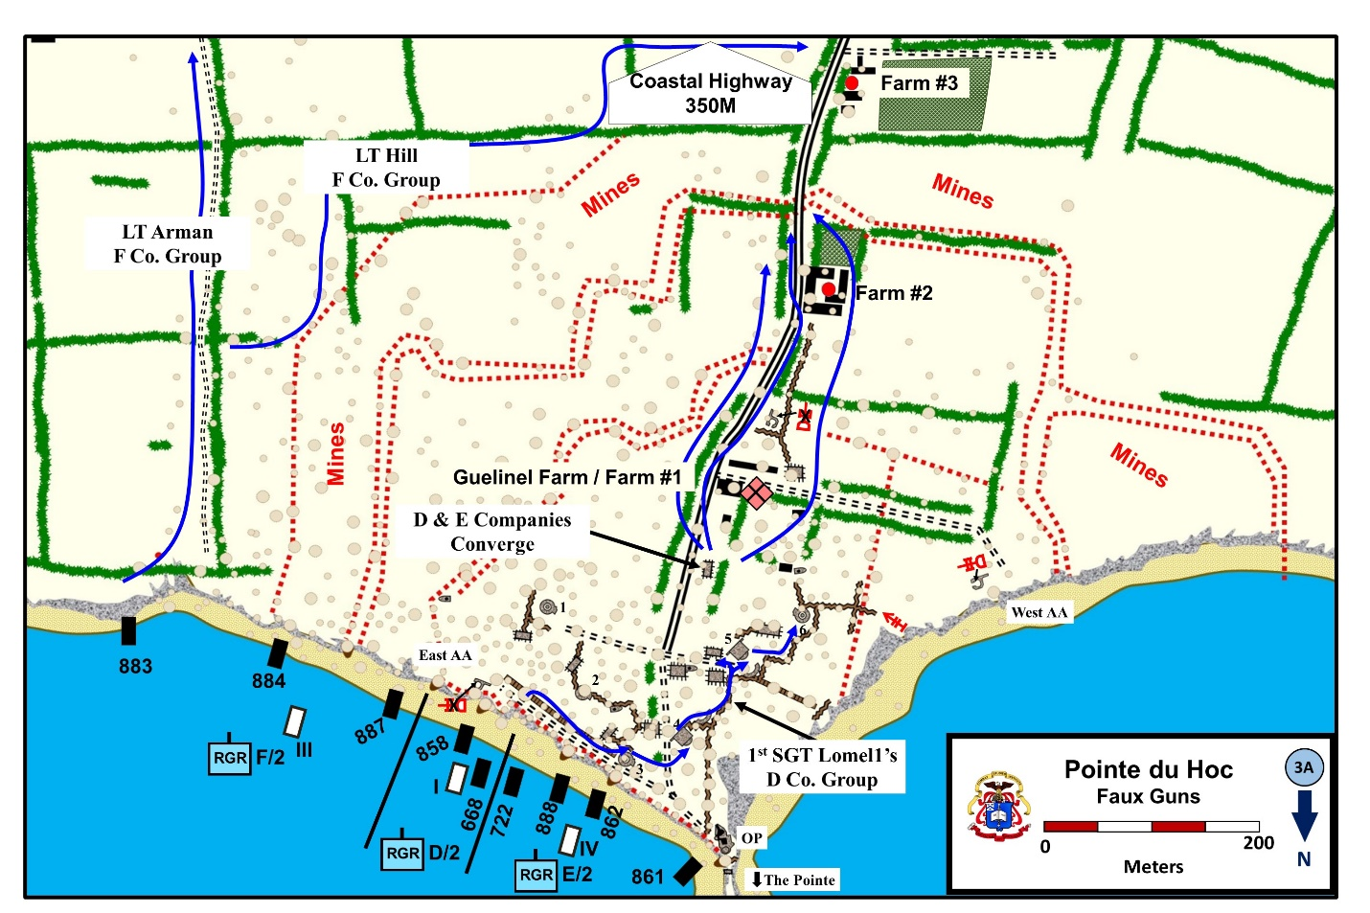
Troops landing at Omaha Beach on D Day have frequently registered, in records and interviews, their disappointment at finding little visible evidence of the preliminary bombardment, which was expected to "make the beach a shambles." No such complaint could be made by the 2d Rangers at Pointe du Hoc. As they came up from the ropes they found themselves in a bewildering wasteland of ground literally torn to pieces by bombs and heavy naval shells. Expected landmarks were gone; craters and mounds of wreckage were everywhere, obscuring remnants of paths and trenches. The Rangers had studied these few acres for months, using excellent photographs and large-scale maps that showed every slight feature of terrain and fortifications. Now, they found themselves in danger of losing their way as soon as they made a few steps from the ragged cliff edge into the chaos of holes and debris. Obtaining cover was no problem, but maintaining contact within groups as large as a squad would be almost impossible during movement.
There were other causes for the "confused" nature of the action that took place on the Point, characterized as it was by infiltration of many and separate groups of Rangers through all parts of the enemy defenses. The prearranged tactics of the Ranger force emphasized movement with the greatest speed and by small groups. As the first few men on a rope reached the top at any point, they moved off at once for their objectives, without waiting for the rest of their boat group, and without taking time to form an organized section or platoon, or attempting to make contact with neighboring parties. In the climbing phase, so intent were the men on their own work that only in exceptional cases was any Ranger party aware of what other boat groups were doing, or even that other boat teams were on the beach. As the later climbers gained the cliff top, they too hillwent off in small groups; over a period of 15 to 30 minutes a series of these parties was forming at the cliff edge and fanning out in all directions. At least 20 of them could be distinguished, but it is as impossible to trace their movements in exact order or timing as it must have been difficult for the Germans to spot the lines of the attack and organize to meet it.

WRECKAGE ON THE POINT caused by bombs and naval gun shells. Photo taken February 1945, looking Inland toward casemates.
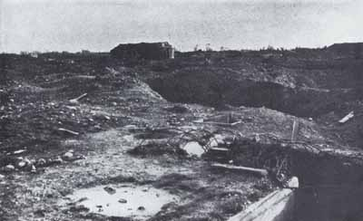
Yet in essence the attack followed a definite plan and order. As first objectives, each platoon (whatever number of groups it split into) had a limited part of the enemy defensive system to reach and deal with. Every man knew what this mission was, and where to go. The outcome was an action without clear pattern in detail, but with very clearly defined results.
1st Sgt Lomell’s (LCA 668, D Co.) experience mirrored that of the several small groups of Rangers that maneuvered toward their assigned objectives. (Details below)

  - He left the cliff top with 22 men and moved toward Gun Position #4. His group most likely passed by pit #2 or #3. However, he makes no mention of the positions because they were not his objective. He did pause near #3 to render basic medical care to Cpt. Buagh (E Co).

  - He then continued on to Casemate #4. He arrived at #4 with about ½ his men.

    - Most of the losses were not casualties, instead small groups had become separated in the confusing terrain or men who had deviated to the flanks to overcome opposition.

    - At #4, they found a faux gun made of wood. Ranger Sigurd Sundby, was unsure of the wires used to construct the fake gun and true to his training decided, “Well, I better cut them, just in case.”

  - Lomell’s group continued on to a large personnel bunker and GP #5 – again there was only a fake gun. He continued to GP #6 and again found a fake gun, and he thought, “Jesus Christ, there’s no guns here. They gotta be somewhere.”

- After examining the gun positions, parts of D and E companies converged on the ruins of the Guelinel Farm (Farm #1). The Rangers secondary mission was block the Coastal Highway and protect the flank of the Omaha Beachhead.

Zaloga, Steven. Rangers Lead the Way, 35 and 39. O’Donnell, Patrick. Dog Company, 75; Ambrose, Stephen. D-Day, 411; & Harrison, Gordon. CMH Pub 7-4-1, Cross Channel Attack, 322.

The first and chief objectives were the gun emplacements and the OP near the end of the Point. Company E had the OP and No. 3 position as its assignment; Company D, the western gun emplacements (4, 5, and 6); Company F, guns I and 2 and the machine-gun position at the edge of the cliff, just east of the main fortified area. Once these objectives were taken, the plan had been to assemble at a phase line near the south edge of the fortified area. From here, D, F, and most of E would strike inland for the coastal highway about 1,000 yards south, cross it, and establish a road block against enemy movement from the west. A platoon of Company E was to remain on the Point with the headquarters group and arrange for perimeter defense of the captured fortifications.
There were, inevitably, deviations from this plan. Some Rangers of Companies D and E failed to reach the assembly area in time for the next phase of movement, or were kept on the Point to meet unexpected developments. On the eastern flank, two boat teams of Company F became involved in an action that lasted most of the day. But, by and large, movement went very nearly according to plan, a plan based on confidence in the ability of small, pick-up groups to work independently toward main objectives. This confidence was rewarded by success.
As the first Ranger elements left the cliff and started for their objectives, they met no opposition except near the OP. Most of the Rangers saw no enemy, and were hardly aware of sporadic fire coming from along the cliff to the west of the Point. Their main trouble was in finding and identifying the gun positions in the wreckage of the fortified area. One party after another reached its allotted emplacement, to make the same discovery: the open gun positions were pulverized, the casemates were heavily damaged, but there was no sign of the guns or of artillery equipment. Evidently, the 155's had been removed from the Point before the period of major bombardments. The advance groups moved on inland toward the assembly area
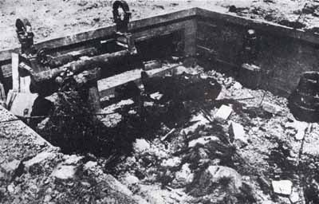
TOP OF GERMAN OP POSITION, looking toward sea (12 June 1944).
The only fighting took place at the tip of the Point. Here, the first men up from LCA 861 found themselves about 20 feet to seaward of the massive and undamaged concrete OP. As S/Sgt. Charles H. Denbo and Private Roberts crawled five feet toward a trench, small-arms fire, including machine guns, started up from slits in the OP. The Rangers threw four grenades at the slits, and three went in. The machine gun stopped firing, but Denbo was wounded by a rifle bullet. Lieutenant Lapres, Sgt. Andrew J. Yardley, Pfc. William D. Bell, and Tech/Sgt. Harold W. Gunther joined up in the trench. Yardley had a bazooka, and his first round hit the edge of the firing slit; the second went through. Taking advantage of this, the group left Yardley to watch the embrasure and dashed around the OP without drawing enemy fire. On the other side of the structure they found Corporal Aguzzi, watching the main entrance from the landward side. Lapres' party pushed on toward gun position No. 4 and points inland.
Aguzzi had come up from LCA 862, southeast of the OP, with Lieutenant Leagans and Sergeant Cleaves. As they started away from the edge, joined by Tech. 5 LeRoy J. Thompson and Pfc. Charles H. Bellows, Jr., they saw a German close to the OP, throwing grenades over the cliff from shelter of a trench. The OP was not their job, but the party decided to go after the grenadier. Bellows crawled over to No. 3 gun position to cover the advance of the party. They threw grenades at the German and moved into the trench when he ducked under the entrance to the OP. Aguzzi found a shell hole from which he could watch the main entrance, while three Rangers tried to skirt the OP on the east and get at it from the rear. Cleaves was wounded by a mine - the only casualty from this cause during the day. Thompson got close enough to hear a radio working inside the OP, looked for the aerial on top, and shot it off. After throwing a grenade through the entrance Lieutenant Leagans and Thompson decided to let the OP wait for demolitions, and went off on their original mission farther inland. Aguzzi, staying to watch the entrance, was surprised a few minutes later by the appearance of Lieutenant Lapres' party, coming from the rear of the OP. Two small groups of Rangers had been attacking the OP from opposite sides, neither aware of the other's presence.
This was not the last group to pass Aguzzi from the tip of the Point. After Lapres' men had moved past the OP, four more Rangers from LCA 861 came up the single rope. As they joined Yardley in the trench facing the embrasure, enemy small-arms fire opened up again. The five Rangers talked it over. They had further missions on the other side of the OP, but there were still enemy in the structure, who could not be left free to bring fire on the men still down on the beach. Medeiros and Yardley considered going down to get demolitions, but decided they couldn't give enough covering fire to get a Ranger close to the embrasure with the explosive. Finally, it was decided to leave Yardley and Medeiros in position to "button-up" the seaward side of the OP while the others went past. With Yardley and Medeiros watching to cover their movement with fire, the three Rangers went along the trench to pass the OP on the west side. Near the end of the trench, small-arms fire came at them from some position on the top of the OP which Medeiros could not spot, and Pfc. George W. Mackey was killed; the two others made it safely to the inland side.
For the rest of D Day and through the following night, Yardley and Medeiros stayed in their trench on one side of the OP while Aguzzi watched the main entrance. Neither guard knew the other was there. Demolitions could have been used on Aguzzi's side, but nobody bothered to bring them up for use; there was no sign of action from the enemy in the OP.
Except at the OP, the first Ranger groups had crossed through the fortified area without seeing an enemy. The last parties to arrive from the beach began to get some evidence that there were still Germans close by. The antiaircraft position just west of the Point put bursts of automatic fire on any Rangers who exposed themselves, and sniping started from the area near gun position No. 6. A group from Company D (LCA 858) was working through that vicinity; their story is known only from the one survivor of the action.
Pfc. William Cruz, slightly wounded on the beach, came up just after Colonel Rudder had moved his CP to the cliff top (about 0745), and Cruz was assigned to guard the CP. He and Ranger Eberle went after a sniper near gun position No. 4, and in doing so drew machine-gun fire from the antiaircraft position to the west. Somebody ordered them to "go after it." When they started out, sliding from cover of one crater to another, they came up with Tech/Sgt. Richard J. Spleen, Tech/Sgt. Clifton E. Mains, and a group of eight or ten Rangers, in cover just west of No. 6 position. This party was considering an attack on the antiaircraft position, but hesitated to open fire for fear of drawing German artillery shells, which were beginning to hit near the fortified area from positions somewhere inland. After a time the Rangers started to crawl through shell holes toward the antiaircraft position, slowed by fear of mines. A German helmet came up out of a crater ahead; the Rangers near Cruz saw the stick under it and knew enough to avoid fire, but somebody just behind them took the bait. Almost immediately, artillery and mortar shells began to search the area. Bunched too closely in a row of shell holes, the Company D party took off in all directions to spread out.
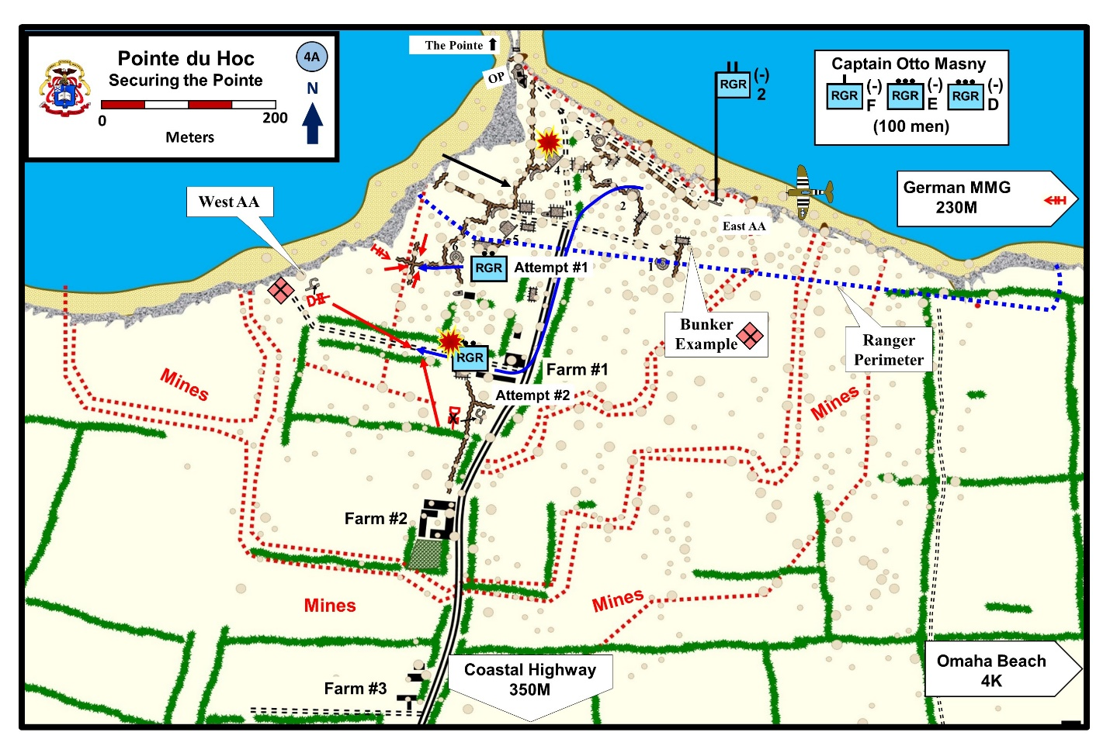
Private Cruz moved back toward No. 6 emplacement, and found himself completely alone in the maze of craters. Yelling to locate the others, he heard Sergeant Mains call "OK." After a 15-minute wait, with enemy fire diminishing, Cruz began to crawl back toward the Point. Just as he reached a ruined trench near No. 6 position, he saw Sergeant Spleen and two other Rangers disappear around the corner of a connecting trench (Ranger attempt #1, Map 4A). Without warning, intense small-arms fire started up, not only from the antiaircraft position to the west but from German machine pistols close by. As he hugged the bottom of the trench, Cruz could hear men moving. A few Germans passed by on his limited horizon, but without noticing him. Then, only a few yards from his hole, guns were thrown into the air; Cruz thought they came up from the trench where Spleen's party had been. Cruz kept quiet, the burst of firing died away quickly, and no one else came in sight. After a considerable wait, Cruz crawled back toward the CP, only 200 yards away. Near the wrecked No. 6 emplacement, he passed a pile of American weapons lying on the ground—8 or 9 rifles, and some revolvers and Tommy guns. He figured these were left there when the Rangers surrendered.
Observation on the Point was so limited that no one else had seen the action or any part of it. Ten Rangers had simply disappeared, with Cruz's report and the abandoned weapons as the only indication of their fate. The best guess was that the Germans had attacked by filtering into the area through wrecked trenches connecting the fortified zone with the antiaircraft gun; as another possibility, they may have emerged from underground shelters on the Point.
Cruz's report served notice at Colonel Rudder's CP that trouble could be expected from the west flank of the Point. In fact, enemy opposition based on the antiaircraft position was to be a source of serious difficulty for the next two days.

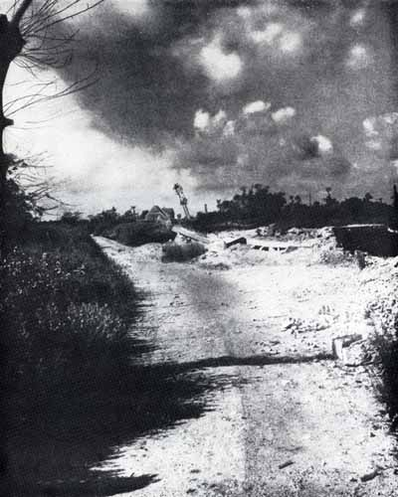
RUINS ON EXIT ROAD, halfway from the Point to the highway. Ranger advance parties began here to encounter scattered opposition from enemy groups near the next farmhouses. (Photo taken June 1945.)
Advance to the Highway
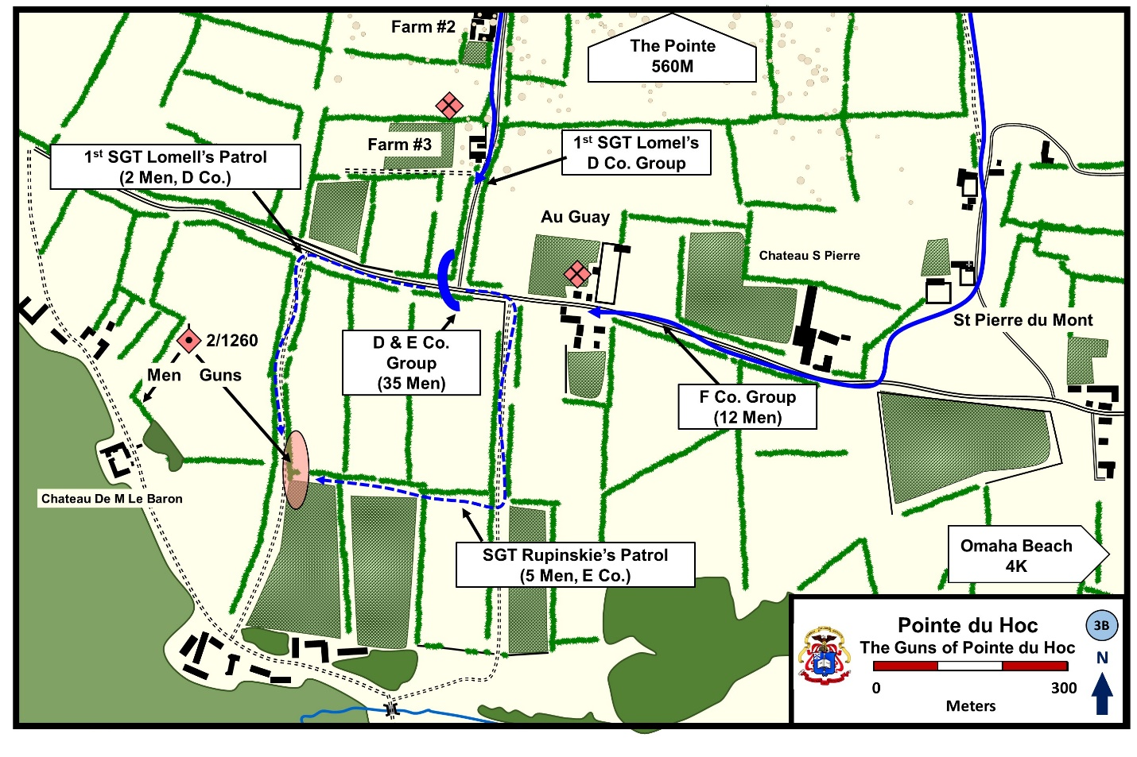
The revival of German resistance at the Point was unknown to the Ranger parties which had been first to cross it, drawing only scattered fire from the western flank. As they passed beyond the fortified area, some artillery and mortar shells began to drop near them, and they were aware of light small-arms fire from ahead (south). This slowed down the leaders, and the original parties of two and three men began to merge in larger groups. The Rangers from Companies E and D (less elements detained on the Point) tended to come together on an axis of advance along the north-south exit road from the Point to the highway. Somewhat to their east, the one boat team of Company F that left the Point area struck south on a course through fields. The early advance inland can best be followed in terms of these two main groups.
The bulk of the group that started down the exit road was made up of Rangers from LCA's 888 (Company E) and 858 (Company D). The party from 888 had come up, after some delay, on extension ladders and started out with 15 men under 1st Sgt. Robert W. Lang. After finding No. 3 casemate a junk-pile of broken steel and concrete, Lang's group moved south. They began to meet artillery fire, coming in salvos of three, and shifting toward the Point with each salvo. Lang stopped for a moment to try for a contact on his 536 radio, with the idea of warning the fire-support party that his men were moving out of the fortified area. He could not make his connection. When he started forward again, artillery fire was falling between him and his men ahead, so Lang turned left into the torn-up fields, where he picked up three stray Rangers of Company E, and then joined a group under Lieutenant Arman of Company F.
The Company E Rangers meanwhile were reaching the assembly area, near the start of the exit road. Here they met up with a dozen men of Company D, who had checked gun positions Nos. 4 and 5 and had left Sergeant Spleen with a few men near No. 6 to deal with enemy who were firing from the antiaircraft position.
The D and E group now amounted to about 30 men. Without waiting for others to arrive, they started along the exit road, taking as much cover as possible in a communications trench along its edge, and keeping in a single file. German artillery, estimated as light guns (75's or 88's), were searching the area with time fire, and from the assembly area onward the Rangers began to meet machine-gun fire from the right flank, and small-arms fire to their left front. They suffered serious casualties in the next few hundred yards: seven killed and eight wounded. Despite these losses, the total size of the force was increasing as it caught up with small advance parties who had left the Point earlier, or as latecomers tagged on to the rear of the file.
The first objective was a group of ruined farm buildings, almost halfway to the highway. German snipers who had been using the building pulled out before the Rangers got there. Fire from destroyers' guns as well as enemy shells was hitting around the farm, and the Rangers made no pause. Ahead, the ground was open, and the trench used thus far in the advance came to an end at the buildings. The next cover, 35 to 40 yards south, was a communications trench that crossed the exit road. To reach it, men were sent out one or two at a time, moving fast and taking different routes across an area exposed to machine-gun fire. The only casualty was a Ranger who fell on a comrade's bayonet as he jumped into the trench.
FARM BUILDINGS ON EXIT ROAD about 200 yards from the highway, reached by Rangers about 0800 on D Day. Opposition ceased beyond this point. (Photo, looking south, taken June 1945.)
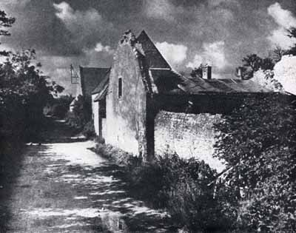
Beyond the trench a pair of concrete pillars flanked the exit road, with a crude roadblock between the pillars. Three Germans came straight down the road toward the Point, spotted the Rangers, and ducked behind the block. BAR fire failed to flush them out, but after one round (a dud) from a bazooka the Germans fled. The Rangers resumed their advance down the exit road. Some machine-gun fire had been coming from the next farm; Lapres reached it with his four men to find the enemy had left. For a few minutes Lapres was isolated there, as machine-gun fire from the flanks pinned down the main Ranger party. Some friendly support fire, which the Rangers could not trace, apparently silenced the machine guns.
This was the last of German resistance, and Lapres' advance party made the final stretch to the blacktop without any trouble. As they came to it they saw Tech. 5 Davis of Company F coming through the fields on their left, and a few minutes later a larger party of Company F men came along the highway from the east. At 0815, barely an hour since the landing, the Rangers had reached their final objective-good time, even though enemy opposition had clearly suffered from disorganization. As the survivors of the group put it later, the reason for the speed of their advance was simple: enemy artillery fire seemed to be "tailing them all the way," and this discouraged any delay.
Most of Company F's parties had stayed near the Point, drawn successively into a fight on the eastern flank. The party that reached the highway was from LCA 887, led by Lieutenant Arman and Sergeant Petty. Petty and three men had left the cliff edge first, found No. 2 gun position destroyed and empty, and then started south on a course about 200 yards east of the exit road. When they reached the outskirts of the fortified area, Lieutenant Arman joined them with five more Rangers, and decided to push toward the blacktop without waiting for the rest of his platoon.
Their course led through what had been marked on their maps as a mined area, wired and dotted with posts set against air landings. The bombardment, which had churned up the ground even this far from the Point, may have detonated the mines or buried them in debris, for they gave the Rangers no trouble. Lieutenant Arman's men could see shells hit along the exit road to their right; for their own part, they saw no enemy. Enemy mortars somewhere to the south put down pattern fire in fields near them, but the fire was apparently unobserved and caused no casualties. The group of a dozen men worked forward in squad column, covering the distance from crater to crater in short bounds. As they came to the ruins of a farm lane, running north-south between hedgerows, Sergeant Lang and three Company E men came over from the east and joined the advance.
Lieutenant Arman led the party straight down the lane, while Petty went left across fields to scout toward the Chateau. There was no sign of enemy on this flank and Petty rejoined at the intersection of the lane with the blacktop highway, where the Rangers turned west, moving along the edges. As they reached the cluster of houses forming the hamlet of Au Guay, a machine gun opened up about 100 yards ahead, somewhere near the road. The enemy had delivered his fire too soon; the Rangers scattered without suffering casualties and began to work around the south edge of the hamlet to reach the enemy gun. Sergeant Petty, with two men, was startled by the sudden appearance of two Germans apparently rising out of the ground, not ten feet away. Petty dropped flat and fired his BAR as he fell. The burst missed, but the Germans were already shouting "Kamerad." They had come out of a deep shelter hole which Petty's men had not spotted. The Rangers found no other enemy at Au Guay, and the machine gun had disappeared when they reached the west side of the hamlet. Within a few minutes Arman's party met the Rangers who had come out to the highway along the exit road.
Beside the two main groups whose course has been followed to the highway, several smaller parties reached the same objective on their own. One of these can be followed in detail; this is worthwhile as illustrating other aspects of a "confused" action. The continuity in this story is furnished by Private Anderson. Landing in LCA 884, he went up on the ladders of the next craft to his left, at the extreme left of the landing zone. On top, he and two other 884 men decided on their own to go after the German emplacement, somewhere near the cliff edge to their east, which was still raking the landing beach with automatic weapons. (They were unaware that some of 883's men had already started on the same mission, nor did they see them during their own effort.) Moving fast along a hedgerow that skirted the cliff, they got to within a hundred yards of the enemy emplacement, could not locate the position of the guns, and decided these must be out of reach below the cliff top.
Reversing course back to the ladders, Anderson left the other two Rangers and joined Pfc. John Bacho and S/Sgt. James E. Fulton, who were just starting south through the fields to make the blacktop. The three men followed along hedgerow lines, using the "Buddy" system, one man covering as two moved, in a leap-frogging advance. Within a hundred yards they caught up with Lieutenant Hill and two other Rangers from 884, going in the same direction. The only sign of enemy was occasional sniper fire. At the first lateral hedgerow they turned west; Bacho and Fulton went through the hedgerow to guard the flanks and lost touch with the others, eventually joining Lieutenant Arman's group near the highway.
Hill's party, now four men, worked west to reach the double-hedgerowed lane, picking up a willing prisoner from the field on their right. Machine-gun fire to the west, near the exit road, drew their attention, and the four Rangers started angling in that direction. As they were passing through a field of stubble wheat, automatic fire came at them from the direction of Pointe du Hoc, and forced them to crawl. So far the gun they were after had not spotted them and was not firing in their direction. About 25 feet from the exit road, Lieutenant Hill and Anderson reached the cover of a low embankment. The machine gun was just beyond the road ahead of them. Hill stood up to look at the position and to Anderson's amazement shouted, "You ... ... , you couldn't hit a bull in the ass with a bass fiddle!" This drew enemy fire; as Hill dropped back into cover, Anderson tossed him a grenade, Hill threw it, and the machine-gun fire stopped. A few minutes later, Lieutenant Lapres came down the exit road with the advance group of Company E, and Hill's action may have saved this party from surprise fire. The four Company F men now served as flank patrol for the further advance along the exit road, moving one hedgerow to the left of Lapres. Anderson, as he neared the blacktop, fired at somebody to the west near the road intersection, but was not sure (later) whether it was a German or Sergeant Lang (see Map 3A).
Another small group led by 1st Sgt Lomell (D Co.) led another small group that moved toward the coastal highway. Once outside the strongpoint, the amount of German small-arms fire and artillery significantly lightened. In some cases Ranger Patrols passed within earshot of German patrols, with neither side actually encountering the other. Near Farm #3, 1st Sgt Lomell hid in a ditch and avoided a German platoon marching past him to the south, “Three men against 35 was stupid, and it would ruin our mission. So we let them pass.”
O’Donnell, Patrick. Dog Company, 84.
The Rangers at the highway numbered about 50 men, with all three companies represented. Their mission was to block movement along the coastal highway; expecting to see the 116th Infantry and the 5th Rangers arrive at any moment on the Vierville road, their main concern was the highway west, toward Grandcamp. Such enemy resistance as had been met seemed to come from west and south, so they made their dispositions accordingly. Bordering the south side of the highway near its junction with the exit road, a series of narrow fields ended in a hedgerow that ran east-west, overlooked orchards sloping down to a creek, and gave some observation across the small valley of the creek. Along the hedgerow they found enemy dugouts and fox holes conveniently prepared on the north side of the hedge. The contingents from Company E and Company F occupied this line for a distance of four fields, two to each side of a lane that ran from the highway down to the creek. An outpost of Company F men went down the gentle slope toward the creek and took position where they could watch the farther side of the little valley. A German dugout near the lane was picked for a CP, used by Lieutenant Arman (Company F) and Lieutenants Lapres and Leagans of Company E. Except for two stragglers picked up in the fields, there was no sign of enemy in the neighborhood.
The 20 men of Company D were given the assignment of covering the west flank toward Grandcamp. [Lt. Kerchner and ]Sergeant Lomell placed his men along both edges of the highway, with a combat outpost at the western end of his line consisting of a BAR man and six riflemen with a grenade launcher. This outpost could cover the road and had good observation toward the valley between the Rangers and Grandcamp. The rest of the Company D men could watch the fields north and south of the highway. Toward the sea, the fields were believed to be mined, and this would simplify defense on that side.
Active patrolling was started at once on all sides of the thinly-held positions. About 0900, a two-man patrol from D went down the double-hedgerowed lane that ran south from the highway near Company D's outpost. About 250 yards along the lane, Sergeant Lomell and S/Sgt. Jack E. Kuhn walked into a camouflaged gun position; there, set up in battery, were five of the enemy 155's missing from the Point. They were in position to fire toward Utah Beach, but could easily have been switched for use against Omaha. Piles of ammunition were at hand, points on the shells and charges ready, but there was no indication of recent firing. Not a German was in sight, and occasional sniper fire from a distance could hardly be intended as a defense of the battery. So effective was the camouflage that Lomell and Kuhn, though they could later spot the guns from the highway, had seen nothing until they were right in the position.
Patrick O’Donnell in Dog Company (pg. 87) states that Sgt Kuhn over-watched Lomell and observed about 75 Germans assembling several hundred meters away in the corner of a field. “The Germans were in various stages of undress. They were putting jackets and shirts on; they were being rallied by an officer standing in his vehicle.”
With Kuhn covering him against possible defenders, Sergeant Lomell went into the battery and set off thermite grenades in the recoil mechanism of two guns, effectively disabling them. After bashing in the sights, of a third gun, he went back for more grenades. Before he could return, another patrol from Company E had finished the job. This patrol, led by S/Sgt. Frank A. Rupinski, had come through the fields and (like Lomell and Kuhn) were in the gun position before they saw it. Failing to notice the fact that some disabling work had already been done, Rupinski's patrol dropped a thermite grenade down each barrel, and removed some of the sights. After throwing grenades into the powder charges and starting a fire, the patrol decided the guns were out of action and withdrew. A runner was sent off at once to the Point, bearing word that the missing guns, primary objective at the Point, had been found and neutralized.
Just why the German guns were thus left completely undefended and unused is still a mystery. One theory, based on the fact that some artillerymen were captured that day on the Point, was that bombardment caught them there in quarters, and they were unable to get back to their position. All that can be stated with assurance is that the Germans were put off balance and disorganized by the combined effects of bombardment and assault, to such an extent that they never used the most dangerous battery near the assault beaches but left it in condition to be destroyed by weak patrols.
LANE LEADING SOUTH from highway, along east side of fields held by advance group of Rangers during D Day. CP of this group was about 300 yards down this trail. (Photo taken June 1945.)
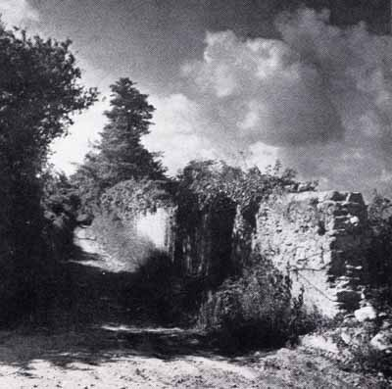

Morning at the Point: Action on the Left Flank
The D-Day fighting at Pointe du Hoc can be followed in terms of two main groups: the force that reached the highway and took positions there, and the Rangers who stayed in or near the fortified area at the Pointe itself. Some stayed according to plan; others were diverted from going inland by circumstance and, above all, by the revival of German resistance near or in the fortified area. Two of the three boat teams of Company F were stopped by this resistance in carrying out their first assignments, becoming involved in a series of actions that held them all day near the cliffs just east of the fortified zone.
LCA's 883 and 884 had beached on this flank, several hundred yards to left of their planned touchdown. Lieutenant Wintz, in command of 883, failed at first to realize that he was facing the cliff s outside the fortified area, and thought bomb damage must be the reason for the unfamiliar look of the terrain. When the first half-dozen men were up the ropes, Wintz sent them out to occupy hedgerows meeting at the southeast corner of the first field inland. Ducking in and out of craters, the men reached the ruined hedgerows without drawing fire; Wintz sent out the rest of the boat team as they came up, except for the mortarmen. Men from LCA 884 were beginning to come up on 883's ladders, as Wintz went along the cliffs to the west looking for the company commander, Capt. Otto Masny. But Masny had gone over to the Point, and Wintz was not to see him until the end of the day.
Lieutenant Wintz had now oriented himself. His men, plus some from 884 (a few others from 884 went off on their own, inland), were just east of the base of the Point. South of them were shell-ploughed fields stretching toward St-Pierre-du-Mont and crossed by only a few hedgerows. Occasional artillery fire and some sniping began from this direction, forcing the Rangers into cover and costing them one rifleman. To the east, about 200 yards along the cliffs from the Company F position, the German automatic weapon (variously described as a machine gun or a light antiaircraft gun) which had caused so much trouble during the landing was now firing toward the Point over the heads of Wintz's men. Except that the gun was somewhere close to the Cliff, its position could not be located.
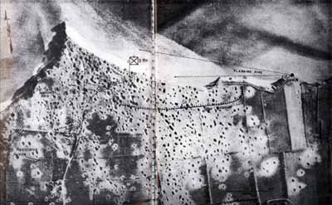
Morning Near the Point
This enemy emplacement, sited to cause trouble for the Rangers still along the beach, was included in the original Company F objectives, and Lieutenant Wintz decided to "go after it" with five men. Sgt. Charles F. Wellage had set up his mortar in a crater near the cliff, ready to fire once the enemy's position was fixed. A hedgerow skirted the cliff edge eastward; using a drainage ditch on the inland side of this hedgerow, the party worked slowly along, making every effort to stay under cover.
As far as Wintz knew, this was the first attempt to get at the troublesome gun cast of the Point. Actually, it was the third-a fact that brings out again the scattered and impromptu nature of the early fighting near the Point, and the difficulties of maintaining control or observation in the cut-up terrain.
By the time Wintz started (somewhere between 0800 and 0830), two other groups had gone east to reach the German gun position. Almost immediately after getting up, Private Anderson and two other Company F Rangers had started out, failed to locate the gun, and returned (see above, page 29). Captain Masny, before he went over to the Point, had sent out a three-man patrol consisting of 1st Sgt. Charles E. Frederick, S/Sgt. Robert G. Youso, and Pfc. Herman W. Kiihnl. They started along an east-west hedgerow one field inland, with Frederick covering the other two for the first move. Someone brought up an order for Frederick to report back to Captain Masny; the other two went on, thinking Frederick was following. They got to within 20 yards of where they thought the gun position must be, and as Youso half rose to throw a grenade he was shot by a German rifleman. Kiihnl went back to find Frederick, while Youso crawled toward safety on the seaward side of the cliff-skirting hedgerow. The two leading Rangers of Wintz's party met him there after he had made about 75 yards.
Wintz's small attacking force was strung out along 200 yards of the cliff hedgerow, with Wintz near the rear, bringing up four more riflemen and an observer for the mortar. The enemy had spotted their movement, and small-arms fire was covering an open space along the route, wounding one man and slowing progress. Nevertheless, the advance was still continuing when an order came from the rear to pull back.
The order had come from some distance and was based on a misapprehension. Sergeant Frederick, called back earlier to report to Captain Masny, had gone as far as No. 1 gun position without locating him. Here, Frederick received the order by word of mouth for bringing Wintz back. Frederick relayed the message, but was worried by it and went further into the fortified area to find Masny and verify the order. When Frederick located his captain, Masny explained that he thought Wintz's party was starting south toward the highway, and the purpose of his order had been to keep them near the Point. Captain Masny did want the German machine gun neutralized, so Sergeant Frederick sent a messenger at once, revoking the recall order and telling Wintz to push the attack. It was too late; Wintz and his party were back in their starting positions, having brought their two wounded in.
Lieutenant Wintz reorganized for another effort, again along the cliff edge. It was the fourth attempt at the flanking gun position. Just after movement started, orders came to halt the attack. The message came on SCR 300, one of the few times that a radio order got through from the CP on the Point to any of the scattered Ranger parties. Colonel Rudder had decided to try naval fire on the cliff strongpoint. Wintz's men were well situated to observe (and enjoy) the results. A destroyer pulled close in,¹ and, according to the Rangers' recollection, seven salvos were used: they blew the top of the cliff into the sea, and that ended the Rangers' troubles with automatic fire from the eastern cliff position, though German snipers continued to operate from that sector.
The Shore Fire-control Party directed the USS Satterlee’s fire unto the MG and silenced it. During the engagement, the destroyer closed to within 180M of the shore.

Black, Robert, The Battalion, 109.
Tt was now well along in the morning (time estimates vary from 1100 to 1200). Before naval fire solved the worst difficulty on the east flank, several hours had been spent in action which illustrated the difficulties of coordinating action among the scattered Ranger parties. Most of the troops from LCA's 883 and 884, originally scheduled to move on to the highway, had become thoroughly involved near the Point and were now kept in the right-angle hedgerow position selected by Lieutenant Wintz at the start of his action. It was suitable for protecting the east side of the Rangers' position from attack.
Morning at the Point: The CP Group
Colonel Rudder had gone on top at 0745, and established his CP in a crater between the cliff and a destroyed antiaircraft gun emplacement. Most of the assault parties had left the fortified area on their several missions, and Colonel Rudder could only wait for reports. Observation in the churned-up wasteland left by the bombardment was very limited, and for the moment there was little that he could do to exercise control. However, there was some work to do near at hand, as the enemy gave disturbing signs of reviving his resistance close to the Point.
According to testimony by the communications section, this was a British destroyer, with spotting done by Lieutenant Johnson, observer of the 58th Armored Field Artillery Battalion. Enemy snipers were active, some of them operating inside the fortified area, and steps were immediately taken to eradicate them. Some of the last parties up the cliff, together with headquarters personnel, were sent out to hunt them down. These efforts, repeated many times, were never entirely successful. Through the rest of D Day, the CP and the whole Point area were harassed by snipers who came out of tunnels and trenches, to find plenty of cover in the cratered debris. Patrols combed over the maze of underground positions, but it seemed impossible to clean them out with the small force available. At no time were the snipers numerous, and there were periods when the Rangers could move in the open with impunity, anywhere on the Point. But these intervals of calm would be broken at any time by scattered small-arms fire from every direction, or by bursts of automatic fire from the German antiaircraft position, 300 yards west on the edge of the cliff. Colonel Rudder sustained a thigh wound from this fire during the morning.
COL. RUDDER'S CP was set in a cratered niche at the edge of the cliff. German artillery searched for it, but most of the enemy shells were "overs" into the sea. Lt. Eikner, in charge of the communications section, is near the center, drinking from his canteen.
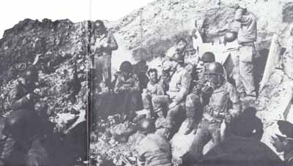
Within a half hour after Colonel Rudder's arrival on top, a first attempt to knock out this western strongpoint had ended with the destruction of Sergeant Spleen's small attacking force (Ranger attempt #1, Map 4A). This made it clear that the antiaircraft position was the main center of enemy resistance near the Point, and the most dangerous because it afforded a base either for attack into the Rangers' foothold on the Point or for efforts to cut off the parties that had gone inland.
Captain Masny, after helping to set up Company F's positions on the left flank, had come over to find Colonel Rudder and was impressed into service at headquarters. He was given the mission of forming a perimeter defense for the CP, using headquarters personnel and any Rangers who had not gone inland. As he was organizing this defense, fire opened up again from the antiaircraft position (Ranger attempt #2, Map 4A, page 23). Like Sergeant Spleen earlier, Masny collected the nearest men at hand and went out to attack. Starting with eight men, the group picked up a few more Rangers as it went through the fortified area toward the exit road, planning to swing west. Among the additions was a mortar section from LCA 722. Much earlier, this mortar had been set up to deliver supporting fire for the Company E group moving inland under Lieutenant Lapres. S/Sgt. Millard W. Hayden had accompanied the group, taking with him a sound power phone and half a mile of wire. No calls for fire had come, and communication had been broken off, so the mortar section decided to move inland and join Hayden. Before they had gone far, they were recalled for support of Masny's group, which also had a 30-cal. machine gun, taken off a dukw.
Masny's force turned west where the exit road met the remains of a lane that led toward the enemy strongpoint. They had made only a hundred yards progress when rifle, machine-gun, and mortar fire opened up, from their left flank as well as from the strongpoint. Scattered among craters, the Rangers started a fire fight, the mortar set up in a hole about 50 yards to the rear of the riflemen where Masny directed its fire. When a white flag showed over the German emplacement, the men with Masny were wary and stayed under cover. But two Rangers on the right of the skirmish line, near gun position No. 6, stood up in the open. Masny's yell of warning was too late to save them from a burst of machine-gun bullets, and the fire fight resumed. German artillery came into action, from somewhere inland. The first rounds were over; the next rounds began to "creep" back until they bracketed the hedgerow-marked lane which was the axis of the Rangers' attack. There the fire held, right on the lane, "the prettiest fire I ever saw" (Captain Masny). His attack was smashed in short order; four men were killed and nearly ever Ranger in the group was hit. Masny, wounded in the arm, shouted "Withdraw! Every man for himself!" after the second burst, and the remnants crawled back to the exit road and over to the CP, with snipers killing two more on the way. All its ammunition shot away, the mortar was abandoned at its firing position.
That was the last effort of the day to assault the antiaircraft emplacement; the two ill-fated attempts had cost 15 to 20 casualties. Several attempts were made to knock out the antiaircraft position by naval fire, with the Satterlee expending many rounds in futile bombardment. The position was just too far from the edge of the cliff to be blasted off by undercutting fire (such as destroyed the emplacement on the other side of the Point), and yet was too close to the cliff to be reached directly by the flat trajectory of the destroyer's guns, from their lower firing level.
At the CP the Navy fire-control party also called in an airstrike on the western flak bunker. A P-47 FB almost attacked the Ranger CP, but the Rangers waved them off with an American Flag and radio calls.
Naval supporting fires nevertheless gave the Rangers inestimable aid, and from very early in the assault. At 0728, the Satterlee made its first contact with the Naval Shore Fire Control Party, and was immediately given target requests followed by spotting reports from the shore observers. However, radio transmission was uncertain (SCR 284), and a new difficulty arose when the signals party moved to the CP on top of the cliff. Attempts to communicate by radio drew enemy artillery fire immediately, suggesting that the Germans were picking up the transmission and using it to register on the CP. Lieutenant Eikner then turned to other means, and made successful contact by signal lamps. These were used with good results during the rest of the day, though radio transmission for fire control was resumed in the afternoon! Personnel of the fire control party observed results not merely from the Point but from positions inland, sending spotting data back to the Point by SCR 536 for relay to the ships. Targets given the Satterlee included inland assembly areas at St-Pierre and Au Guay, road junctions, strongpoints toward Grandcamp, and, especially, the antiaircraft position west of the Point. By 1723 the Satterlee had expended 70 percent (the prescribed maximum) of her ammunition, having fired 164 salvos, plus six minutes of fire for effect, in support of the Rangers since H Hour. The Barton and Thompson moved in near the Point to relieve the Satterlee, and before dark the NSFCP transmitted data for night fire on road junctions and other targets.
Little success was had in communicating with friendly ground forces, either the 5th Rangers or 29th Division units. Apparently the SOI had been changed just before D Day without notification to Colonel Rudder's communications section; though Lieutenant Eikner more than once contacted friendly units ashore at the main landing beaches, he was unable to get any answers or to stay in touch. He attributed this to his inability to give proper authentication to his messages. Colonel Rudder thus was in complete ignorance of the progress of the great assault at Omaha Beach, for the naval vessels, if they had any information, did not send it to the Point. Between noon and 1300 Colonel Rudder sent out a message by all available means, SCR 300, SCR 284 (through the Satterlee), and pigeon: "Located Pointe du Hoc—mission accomplished—need ammunition and reinforcements—many casualties." By 1500 the 116th Infantry replied, stating its inability to decipher the message, which was repeated. About the same time, the destroyer relayed in reply a brief message from the 1st Division commander, General Huebner: "No reinforcements available." The Rangers' noon message was the only word received from Pointe du Hoc on D Day by higher headquarters (V Corps had it by mid-afternoon), and was the cause for considerable anxiety as to the Rangers' situation.
The medical section with the Ranger assault force passed a busy morning. Capt. Walter E. Block and two of his enlisted personnel came in on LCA 722; three aid men were distributed in other craft. The aid men had pack carriers with 50 feet of rope coiled on top, so that if enemy fire made necessary a quick crossing of the beach the packs could be left behind and pulled over later. The two men with Captain Block carried aid kits, and Block himself lugged an 81-mm mortar shell case, waterproofed to serve as a container for medical supplies. All the equipment was got to the cliff base in good condition. When the CP moved to the top, Block left one man to care for some seriously wounded Rangers who could not be moved from the beach. Later in the morning one of the aid men and Lt. Col. Trevor, British Commando officer who had accompanied the assault, assembled sections of an extension ladder on the beach and got it mounted conveniently for service in moving wounded and getting supplies up the cliff.

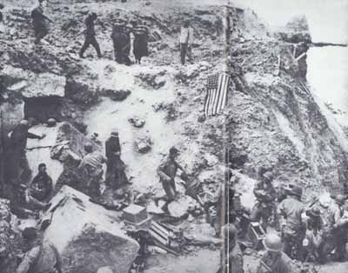
AFTER RELIEF ON D+2, when American flag had been spread out to stop fire of friendly tanks coming from inland. Some German prisoners are being moved in after capture by the relieving forces.
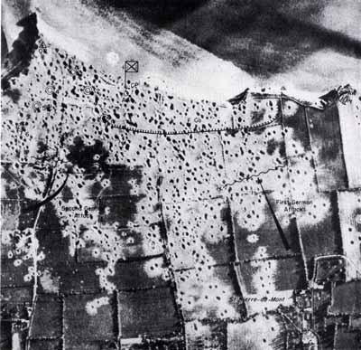
MAP NO. 6-Afternoon Counterattacks, X-Area reached by German counterattacks. Y-Enemy resistance areas.
Colonel Rudder and Captain Block were concerned over the problem of caring for the considerable number of wounded, many of whom needed to be evacuated. At 1350, by signal light communication, the destroyer Barton was asked to send in a boat to take off the casualties. At 1430, a small motorboat from the Barton made the attempt, towing a rubber boat astern. Enemy machine-gun fire from along the cliff s east of Pointe du Hoc harassed the Barton's motorboat, wounding one of the crew and preventing a landing. Block had to leave several of the seriously wounded Rangers overnight on the beach, in a cave at the base of the cliff.
Afternoon Counterattacks
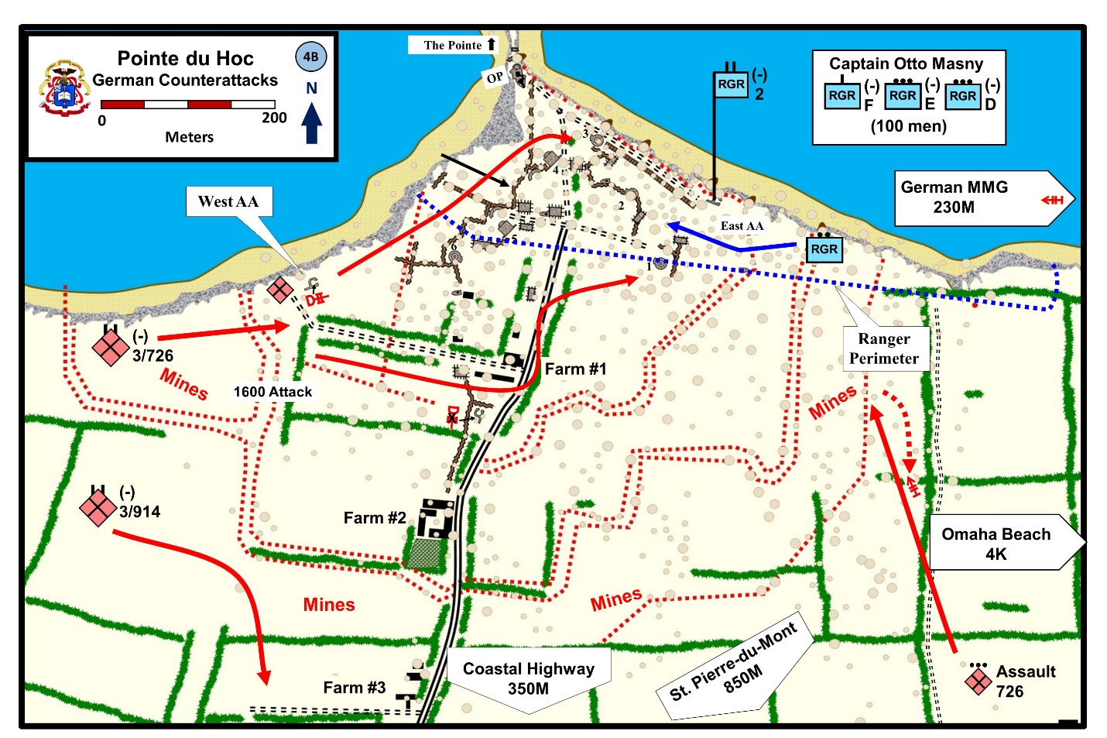
The Germans made two efforts against the Point during the afternoon, both of them hitting Lieutenant Wintz's force from south and west. The first attack came over the fields that stretched toward St-Pierre-du-Mont, where Lieutenant Wintz's Rangers spotted riflemen coming through the craters, with at least one machine-gun section. When the enemy reached the hedgerow one field south of Wintz's line, they set up the machine gun and started a fire fight that went on for an hour. Some artillery and mortar fire supported the effort, but most of the enemy shells went over into the Point area. Company F had a mortar in position, but it was short of ammunition and held its fire. They had no BAR's on the flank facing the attack, and naval fire could not be called on against the Germans so close to the Ranger lines. The attack was met and stopped by well-sustained rifle fire; after a time the German fire weakened and men could be seen drifting back. Wintz's force sustained no casualties.
Initial German Counterattack was not a major effort. The 352d IN DIV was aware of the attack at the Pointe. However, due to the troubling events at Omaha the news was not particularly alarming. Only the assault platoon of the 726th Grenadiers was sent to counterattack what they believed to be a commando raid.

Zaloga, Steven. D-Day 1944, 79.
The next German effort came shortly after 1600 and was much more dangerous [elements of the III/GR. 726]. It hit the right end of Company F's thin line. Two BAR's as well as the mortar section were on this wing, but only a few riflemen, and the right flank (toward the antiaircraft position) was "in the air." Moving near the exit road, the Germans were close in on this flank before they were observed. S/Sgt. Herman E. Stein and Pfc. Cloise A. Manning were near gun position No. 1, changing craters after a close burst of enemy shells, when they saw a dozen Germans, with a machine gun, almost due west and moving fast toward the Point. About the same time S/Sgt. Eugene E. Elder, at the mortar, spotted some enemy to the south, close by and crawling through craters. Sergeant Stein opened with surprise fire from his BAR at 40 yards, hit a couple of men in the group to the west, and scared the others into a short withdrawal.
This check disorganized the attack for a few valuable moments; when the Germans rallied, their firing line extended well beyond Company F's flank, but their fire was high and wild. The few Rangers on that wing took hurried measures to meet the danger. Stein sent a message over to the mortar position, warning of the enemy's location, and eight riflemen came over from the left to help defend against any thrust behind Company F and onto the Point. With Sgt. Murrell F. Stinette observing and relaying corrections by call to Sergeant Elder, the Rangers' mortar opened at 60-yard range. The first shells burst right on the advance group of enemy, driving them out of their holes into a hasty withdrawal. Shifting its fire a little south, the mortar flushed another German party, who suffered casualties from the BAR's as they ran for cover.
That was the end of an attack that had got in very close to the Point and threatened to cut off Wintz's group. Quick reaction by the Rangers, and very rapid and accurate mortaring, had knocked the enemy off balance and given them no time to recover. A mortar in the attacking force was never used; their two machine guns were set up a few times, only to be chased into new cover by Sergeant Elder's mortar. Elder fired about 75 rounds during the action, all without increments, which had been wetted in landing. He found that the mortars could be used effectively at the short range, making the range changes accurately enough by calling for turns on the elevation and traversing handles.
Until darkness fell, there were occasional light skirmishes with German riflemen still in the fields beyond Lieutenant Wintz's position. The enemy seemed to be trying to feel out the Ranger strength on the east flank, but no more attacks developed. Toward nightfall, Lieutenant Wintz drew in his forces toward the Point to form a closer perimeter defense. The men were scattered through convenient shell holes, close enough to call to each other. Wintz took a patrol through the whole Point area, including the gun positions, to search out the snipers who were still appearing behind the perimeter. He failed to locate a single enemy.
The Company F men from LCA's 883 and 884, numbering originally about 40, had suffered casualties of 5 killed and 10 wounded during the day's fighting on and near the Point. Among the killed were Lieutenant Hill, who had gone out beyond the highway in the morning with the advance parties. (See page 30.) Toward afternoon, Hill started back to the Point, to report to the CP. On the way in, Lieutenant Hill and Private Bacho heard machine-gun fire in the fields cast of the exit road and went over to investigate. About 300 yards away from the Company F line, they started across a hedgerow to get at a machine gun which Hill had spotted two fields over to the east. Bacho looked over the hedgerow and saw a dozen Germans lying on the open ground in a field corner, talking. Hill decided to grenade them. He and Bacho threw their first two over the hedge, then lumped into a ditch. The grenades misfired and stirred up a hornet's nest. The startled Germans began to throw their "potato-mashers"; one exploded harmlessly right between Hill and Bacho, but in the next instant Hill was shot through the chest by a machine-pistol bullet. Bacho threw over his remaining grenades, including one with thermite charge which "seemed to confuse the enemy," and inflicted some casualties. When a rifle bullet went through the top of Bacho's helmet he decided to play dead. The Germans came up to the hedgerow and looked over, but concluded the Rangers were finished. Sometime later Bacho was able to crawl away to a crater. He spent the afternoon in the general area through which the first German attacks were coming, but, though he heard shots fired around him, Bacho saw no Germans and had no idea that an enemy counterattack was under way. At dark, he was able to get back to the Point.
- There were times when the Naval gunfire fell short. Late in the morning, LTC Rudder was wounded again. One of his men had repaired a German radio in GP #4. Rudder and part of his command group went to the bunker to use the radio.

- However, I shell from the HMS Glasgow fell short and hit the bunker. The shell killed the Army Artillery Observer (Captain Harwood) and Rudder’s radio man. It also wounded the Naval Fire observer (Lt Norton). Rudder received splinters of concrete into his right arm, but stayed in the fight.
Zaloga, Steven. Rangers Lead the Way, 42-43 and Black, Robert. The Battalion, 134

The Advance Group During D Day
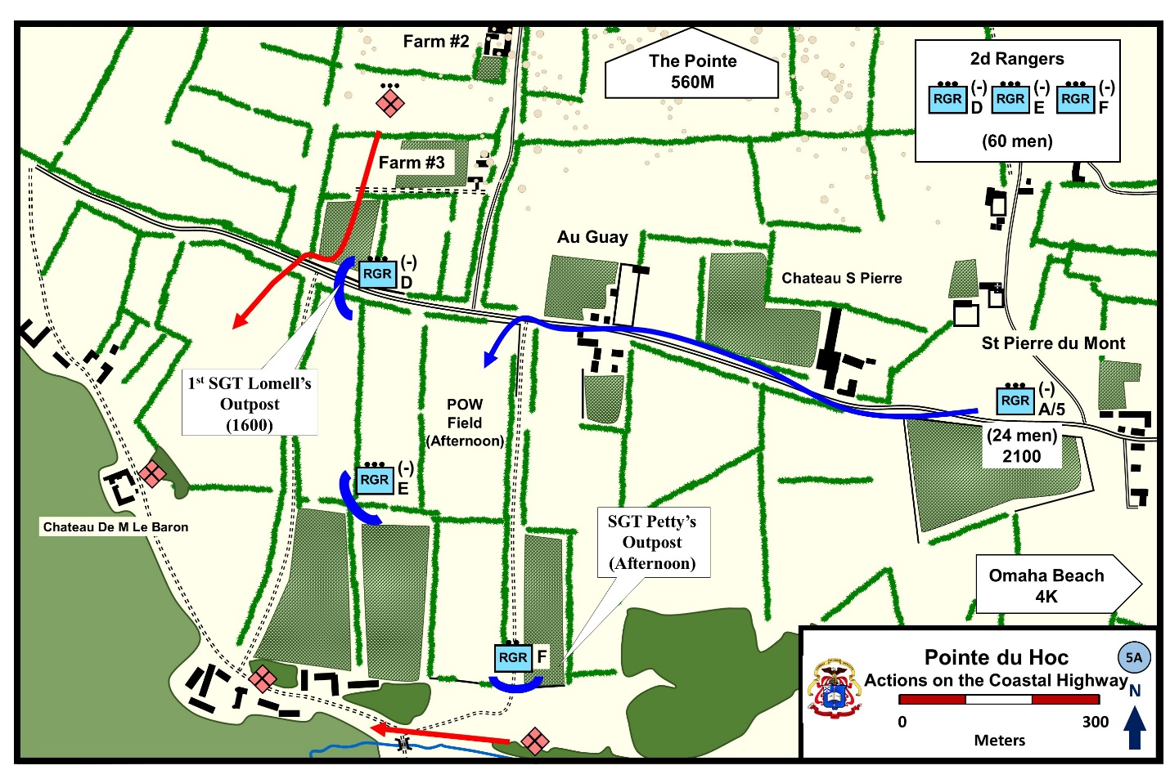
For some time after the highway was reached, small parties of Rangers drifted in to join their platoons, so that by noon there were over 60 men to hold the forward position, a half mile inland from the Point. Among the arrivals were three paratroopers of the 101st Airborne Division, scheduled to drop early that morning north of Carentan, 15 miles away, but dropped instead near Pointe du Hoc.
The main action of the day was vigorous and continued patrolling, undertaken by combat patrols of six or seven men who went out on the flanks of the highway position, and particularly to the south into the small valley. The patrols found no organized enemy positions and encountered no strong forces. A number of Germans who had evidently been bypassed near the Point and were trying to work south straggled into the Rangers' positions from the seaward side and were killed or captured. Patrols rounded up other scattered enemy groups.
Typical of the way men on both sides were cut off and isolated during the first two days was a capture within the Ranger lines. About noon Sergeant Petty came back to the CP to get a rifle for one of his men. Just as he arrived, Sgt. James R. Alexander fired his BAR back toward the highway at two Germans who appeared by a gate, halfway down the lane. One German fell, and Petty and Alexander went over to examine the body, three other Rangers tagging along for no particular reason. Petty was sitting astride the gate, looking at the dead German, when somebody yelled "Kamerad" from the ditch bordering the lane. Three Germans were coming out of the ditch. Sgt. Walter J. Borowski fired some shots into the hedgerow on the chance that there might be more men hiding. Two more Germans came out. Then the hedgerow was searched in earnest, but without further results. Two of the prisoners, a captain and a noncom, said they had had a machine gun, which the Rangers were unable to find. Altogether, about 40 prisoners were taken in by Ranger patrols and outposts, to be grouped under guard in the field near the CP.
Sergeant Petty also figured in a good deal of shooting that took place at the outpost south of the CP and near the creek. He and his nine men were well situated to watch movement across the valley. At intervals during the day small groups of enemy came into easy range, moving west along the country road toward Grandcamp. Perhaps fleeing from the Omaha area, these parties seemed to be disorganized, and put up no fight when Petty opened fire with his BAR. Using surprise fire, Petty inflicted some 30 casualties during the afternoon, including 2 of a party of 7 Poles, shot at before the Rangers realized they were coming forward to surrender.
Patrols found evidence late in the day that the Germans were present in some strength south and southwest of the Rangers' highway positions, but there was no sign of preparation for counterattack. The nearest approach to trouble came north of the highway, near Company D's roadblock. About 1600 Sergeant Lomell, near his CP hole where the highway was joined by the lane containing the German battery, happened to glance over the 5-foot stone wall edging the highway and saw a German force of about 50 men coming through an orchard from the direction of the Point. The enemy was moving in well-organized fashion, with scouts out ahead, and Lomell could see two machine-gun sections and a mortar. There was no time to make any preparation, or even to pass word down the Ranger line. Lomell could only hope that the enemy would pass by and that his own men would have the sense to hold their fire, for the 20 Rangers of Company D, scattered along 150 yards of highway, would have had little chance against a force this size. But the Germans were not attacking, nor, as their course soon made clear, were they aware of the Rangers' position. About 30 feet from the wall the column turned westward and moved parallel to the highway beyond the roadblock position, then south across the blacktop and out of sight. Showing excellent control, the Rangers had made no move that would betray their location.
Intermittent harassing fire fell near the Rangers during the day, but the air and tree bursts caused only one casualty, a paratrooper who got tired of ducking into his fox hole and was hit by the next shell. From the sea, friendly destroyer fire was being directed from the Point at inland targets. Occasionally rounds fell short or uncomfortably close; little could be done about this as communication from the forward group to the Point depended on runners and patrols, and no member of the Naval Shore Fire Control Party was available for the highway group. Men going back to the Point were nearly always engaged by snipers, and sometimes had to fight their way on both trips as German resistance revived near the Point. Lieutenant Lapres twice went back to Colonel Rudder's CP, getting ammunition and, on one trip, a radio which failed to work. On his morning passage, Lapres drew heavy fire from west of the exit road; his attempts in the afternoon were entirely blocked off by Germans who had infiltrated between the two Ranger Groups.
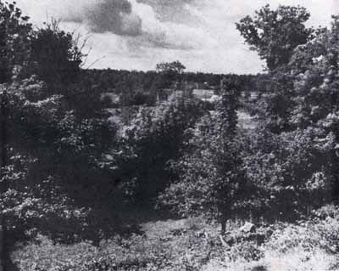
ORCHARD SOUTH OF RANGERS' POSITION, looking toward the small valley. Sgt. Petty's BAR outpost was in position near here to interdict enemy movement along the valley during daylight.
About 2100, still two hours before dark, a party of 23 men from Company A, 5th Ranger Battalion came into the Ranger lines from the east. Led by 1st Lt. Charles H. Parker, Jr., this force was the 1st Platoon of Company A. The record of its fight from Omaha Beach to the Point is one of the sagas of D Day. Parker's platoon became separated from the 5th Ranger Battalion during the first penetration of the German beach defenses between Vierville and St-Laurent, about 0815. Unaware that the battalion had become involved in a fire fight just inland from the beach, the platoon had made its way south of Vierville to the battalion assembly area. Finding no friendly troops there, Parker concluded they must have preceded him and set out west. After fighting two hot actions, one of which netted a score of prisoners, while the other nearly trapped his platoon, Parker got cross country all the way to St-Pierre-du-Mont and walked into the 2d Ranger position at the highway. He was surprised to learn that the 5th Rangers had not arrived, but was sure they must be close behind him on another route. A patrol was sent in at once to Colonel Rudder with this heartening news. Parker's men stayed with the forward group at the highway as they prepared their night defenses.

The German Night Attack: First Phase
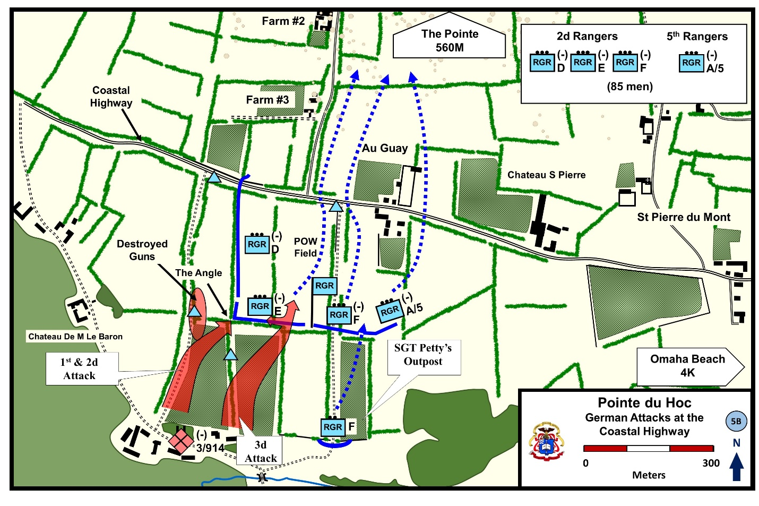
Twilight in early June, on reckoning by British War Time, lasted until 2300. As night approached, and still no word came from Omaha Beach, Colonel Rudder faced a difficult command decision with regard to disposition of his limited forces. Of his original 200 men over a third were casualties, though many of the lightly wounded (including Colonel Rudder) were staying in action. Ammunition was low, especially in grenades and mortar shells. The Germans were still holding the antiaircraft position close to the Point on the west, and had shown themselves in some force on the eastern flank as well. Communications between the Point and the highway group had always been precarious, and the latter force, numbering more than half of the Rangers, would be particularly exposed to counterattack that might cut it off from the shore. Either of the two Ranger positions was in danger; Colonel Trevor, the Commando officer, remarked casually in the CP that "never have I been so convinced of anything as that I will be either a prisoner of war or a casualty by morning."
Colonel Rudder decided to leave the highway force in place. He was still expecting the arrival of the 5th Rangers and 116th Infantry units along the Vierville road, carrying out the D-Day program, and this expectation had been strengthened when Colonel Rudder heard that Parker's platoon had actually arrived, reporting (erroneously) that the rest of the 5th Rangers were probably just behind them. It was important, Colonel Rudder thought, to maintain the block on the Grandcamp highway and so deny that vital road to the enemy. Even though German resistance had stiffened during the day, their counterattacks against the weaker force on the Point had been ineffective, and they had made no efforts against the highway position. As a final consideration, Colonel Rudder and his staff had very strong fears (proved by the next day's experience to be unfounded) of the danger from German artillery if his force were concentrated in a restricted area at the Point. Lieutenant Lapres, who had reached the Point with a patrol just before dark, went back inland with orders to hold the position.
Out beyond the highway, the Rangers made a few alterations in their positions to get ready for night defense. The main indications of enemy strength were to the south and west, and the greater number of the 85 men at hand (including Lieutenant Parker's platoon of 5th Rangers) were disposed to guard against attacks from those quarters.
The day positions of Company D were obviously too extended for safety, and its 20 men were drawn in to form the right flank of the main Ranger position, on a hedgerow that ran south from the highway to Company E's fox holes. Lieutenant Kerchner and a BAR man were at the angle formed by intersecting, hedgerows where E and D joined; Sergeant Lomell was near the center of D's line. Two men were put out west of Kerchner's post, about half way to the lane bordering the next field. Another outpost of two Rangers, one with a BAR, was in the angle where that lane met the blacktop. The rest of Kerchner's men were strung out at wide intervals along the 300 yards of hedgerow, in a ditch running along the embankment.
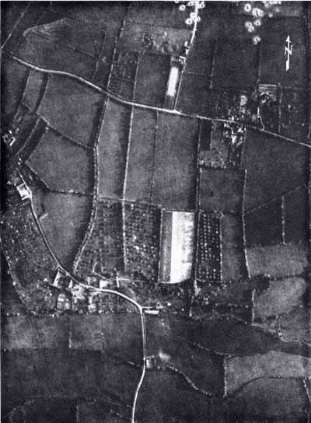
AREA OF HIGHWAY POSITIONS (photo taken May 1944).
Company E's 30 men held their day positions on the hedgeline running east toward the main CP. Some half dozen of the 5th Ranger men were distributed along their front. A few yards south of the angle where E and D connected, two riflemen were posted in the orchard that sloped away gently toward the creek; two more Rangers, one a BAR man, were 75 yards further out. The post of Lieutenant Leagans (2d Platoon) was in a German-prepared dugout near the middle of E's hedgerow, with a BAR man and a rifleman in the corner of the orchard on the other side of the hedgerow, and another rifleman 50 yards south on the boundary between the orchard and a wheatfield. A third BAR man was 20 yards west of Leagans' station. Between Leagans and the angle where Company D's line began, about 10 riflemen occupied fox holes north of the hedge, one group fairly close to the angle and the rest bunched near Leagans, an arrangement thought better for purposes of communication. From east of Leagans' post over to the main CP on the lane, the 1st Platoon of Company E and some 5th Rangers continued the hedgerow line, with main strength near the CP, where the Rangers were placed two to a fox hole for greater safety in night fighting. Sergeant Robey with a BAR was in the corner of the wheatfield just south of the CP, with a good field of fire to the southwest. In addition to their own four BAR's, Company E platoons had found and set up three German machine guns (two model '34's and one '42), for which ammunition was available.
East from the CP, the line that Company F had held in daylight was shortened to 100 yards. Near the lane that ran back from CP to highway, three Rangers with a BAR were placed in a trench that gave them a field of fire through a gateway into the orchard southeast of the CP. Beyond them were two men of Company F and some 5th Battalion Rangers. Sergeant Petty and seven men, including some 5th Rangers, still held an outpost along the stone wall at the foot of the wheatfield. Their advantages of observation from this position would be sharply reduced at night, and Petty was under orders to withdraw if an attack developed in his vicinity.
The main Ranger position thus formed a right angle, facing southwest, with equal sides about 300 yards long on two fields that ran back to the highway. The 30 or 40 German prisoners were put in fox holes in these fields, not far from the CP, and two Rangers were regarded as sufficient guard. Little concern was felt for the open flank to the east, protected by three men with a BAR near the highway, and by a half dozen of Parker's 5th Rangers along the lane between the CP and the road.
Certain features of the night arrangements are worth noting, in view of later developments. The 5th Ranger platoon of 23 men had been scattered in small batches at various points and did not operate as a tactical unit under Lieutenant Parker. He and his assistant, 1st Lt. Stanley D. Zelepsky, were at the main CP with Arman and Lapres. Command functions in the Ranger force, made up of elements of four companies, were not centralized. During the day, the D, E, and F parties had cooperated on a more or less informal basis, with coordination secured by consultation of the four officers, Lieutenants Kerchner (D), Leagans and Lapres (E), and Arman (F). When plans had to be made in the morning as to positions for the day, Lieutenant Arman was the senior officer at hand and seems to have made the decisions. After that he did not consider himself in command in any formal sense. The decision to shorten up and tighten the defenses for the night was taken when Lieutenant Kerchner came over to Arman's post and reported seeing Germans in some strength to the southwest. Arman, Lapres, and Kerchner talked it over and agreed as to readjustment of positions.
As they settled in for night defense, the main worry of the Rangers was their ammunition supply, now running short, especially for the BAR’s. Very few U.S. grenades were left; although a plentiful supply of German "potato-mashers" were found in prepared positions around the CP, the Rangers had a poor opinion of their effectiveness. A few Rangers had lost their rifles and were using German weapons, for which ammunition was in good supply. Companies D and E had three Tommy guns each, and E had three German machine guns. The Rangers had had nothing to eat since leaving the ships except the individual D-bars, but in the excitement and activity of the day few men had felt the need for food.

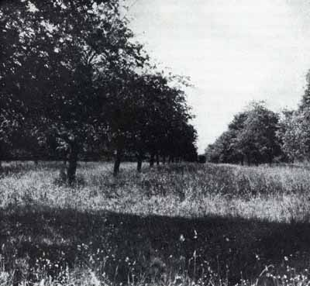
TYPICAL NORMAN ORCHARD. This one was on the south edge of the 2d Rangers' position, the night of 6 June, near coastal highway. Germans approaching the position through the orchard were able to get close before they were spotted. (Photo taken June 1945.)
Even before Lieutenant Kerchner's report, the officers had felt particularly apprehensive about the area southwest of their angle position. At the bottom of the little valley to the south, a country road ran more or less parallel to the Ranger lines, west from a bridge close by Sergeant Petty's outpost and then northwest toward the highway. From their higher ground, the Rangers could watch this road during daylight, but at night it was too far away for good observation. Houses, hedgerows, and orchards along it would give cover for assembly of troops. It was in this area, a few hundred yards southwest of the angle in the Rangers' right position, that Lieutenant Kerchner had observed German activity at dusk.
Despite a moon nearly full and only partly obscured by clouds, the Rangers found visibility poor in front of their angle, particularly into the orchards on the south. Here the ground sloped off 30 feet in 300 yards, and the fields of fire had been good for a daylight action.
- During daylight hours (0600 to 2200), supporting fire from the destroyers off shore was critical to the Ranger defense.
  - Amazingly, the Rangers had no radio to coordinate the fire with the Navy. They had to send a patrol back to the Ranger CP at the cliffs with the fire support request – about 1000 meters to the rear. [Lt. Lapres (E/2) served as an LNO and made several trips between the highway and the Pointe).

  - There was no way to adjust the fire other than to send another patrol back with the changes.

  - At 1950hrs, the USS Thompson fired on concentration of troops from the I/GR. 914 around the Chateau de M. la Baron. The Thompson’s first salvo hit the chateau and forced the German company concentrating there to wait till dark to stage their attack.

- Shortly before nightfall (2200), the Rangers coordinated another naval strike against seven targets around their perimeter.
About 2330 – 30mins after sunset, elements of the I/GR. 914 (3d and 4th Companies) initiated its attack against the Rangers. The Rangers posted in front of the D-E corner were startled by a general outburst of whistles and shouts, close by on the orchard slope. Enemy fire opened immediately and in considerable volume. Sgt. Michael J. Branley and Pfc. Robert D. Carty, in position west of the corner, saw tracer fire from a machine gun to their right and only 25 yards from Company D's side of the angle. South of the corner, in Company E's outpost, the men spotted another machine gun to the west, about 50 yards from Company E's defensive line. Neither outpost had seen or heard the enemy approach through the orchard. At the angle, and along E's front, the Rangers returned the enemy fire at once, the BAR's firing in full bursts. Carty and Branley started back toward the corner to get better firing positions; Carty was killed by a grenade, and his companion, hit in the shoulder by a bullet, managed to crawl to the hedgerow.
In the Company E outpost, Corporal Thompson and Hornhardt were almost walked over by a group of Germans who came suddenly around a hump in the north-south hedgerow dividing the orchard. Thompson saw their silhouettes against the sky, so the Rangers got in their fire first at point-blank range and knocked down three of the enemy. The others went flat and threw grenades, one of them exploding in Thompson's face and cutting him badly. He gave his BAR to Hornhardt and they started back for the corner.
Only a few minutes after the firing began, an immense sheet of flame shot up over to the west, near the position of the abandoned German guns. (The Rangers' guess was that, somehow, more powder charges had been set off in the ammunition dump.) The orchard slopes were fully lit up, and many Germans could be seen outlined against the glare. The flare died almost at once, and the firing ended at the same time. It is possible that the powder explosion had disconcerted the Germans and ended their effort,, but more probably the attack was only a preliminary probe by combat patrols, trying to locate Ranger positions by drawing their fire.
This brief action brought about a few changes in the Ranger positions, affecting the outposts and the west side of the angle (Company D). Certain things that happened began to show some of the difficulties of night fighting. Thompson and Hornhardt got back to the corner and found nobody at that position; when they called for Sergeant Rupinski there was no answer. (He was 20 yards away, to the east, but did not hear them; there were two Company D men close by with a BAR, but Thompson missed seeing them too.) The outpost pair decided everybody must have pulled back across the field, so they started north along Company D's hedgerow and finally encountered Rangers in position near the highway end of the hedgerow. (They had passed others on the way without spotting them in their holes under the hedgerow.)
Lieutenant Kerchner and Sgt. Harry J. Fate were now at this end of the Company D line. When the firing began, with greatest concentration near Kerchner's post at the angle, he had the impression that the attack was going to roll right over them. So he and Fate went north along the hedgerow; as they started, Kerchner told Fate his plan. He would collect the D platoon near the highway, circle west and then south, and hit the German attack in the flank. Kerchner called to his men to follow as he ran along the hedgerow, but in the general uproar of the fire they failed to hear him. On reaching the highway he found only two men had joined up; the fire fight was already dying out, and the plan for a counterattack was given up. Lieutenant Kerchner decided to stay near the highway.
The net result of these shifts was to weaken the angle position toward which the German attack had come. Both outposts to south of it had come in, the two 5th Ranger men appearing at the main CP and telling Lieutenant Arman that they had been ordered to withdraw. (There is no way of tracing whether, why, or by whom such an order was given.) Two Rangers who had been near the angle were casualties; six others, including a BAR man and the only officer at that sector (Kerchner), had gone to other parts of the line. No information on these changes in strength at the angle seems to have reached Lieutenant Arman's CP. Neither Lieutenant Kerchner on D's thinly held front, nor (apparently) Lieutenant Leagans in Company E made any move to strengthen the corner position. So far as can be determined no one visited the corner to see what the situation was.
On the east wing of the Rangers' position there had been no firing. Neither the first platoon of E (Lieutenant Lapres) nor the Company F men had been involved so far. Down near the creek, in Sergeant Petty's exposed outpost, the men were alarmed by the fire but couldn't locate it; they thought it was back near the highway, and some even believed it was the 116th pushing along the blacktop to relieve the Rangers at the Point. Petty, a little after the skirmish ended and quiet had settled down again, heard "clinking" sounds over toward the farm buildings west of his post. He put it down to noise made by farm animals. But after another short spell of quiet, a machine gun opened up from that flank, some of the shots ricocheting off a farm roller which Petty had placed against the stone wall for cover to his right. Petty's men stayed quiet, and after two short bursts the enemy fire stopped. Petty decided, in accordance with earlier instructions that he should pull back up the slope to the CP. His group made the trip without drawing enemy fire. Petty with his BAR and Dix with a machine gun reinforced the CP position, while the rest of his men were put on the Company F line farther east.
At the CP, where Lieutenant Arman was stationed and to which other officers came occasionally, everything was quiet. After the fire fight ended, one or two Rangers from E's line reported in, and Lieutenant Lapres went over to the west to see what had happened. Two noncoms went along the E front to see if there were any casualties and if weapons were working properly. They passed word to expect more attacks. Lieutenant Arman was not informed in any detail of Company E's situation, and knew nothing about D. As far as Company F was concerned, he thought for a time of moving it south toward the creek, to bring flanking fire on any further German attack toward the angle, but decided against this idea because of the danger of firing on friendly positions. The group of German prisoners near the CP was moved farther out, into the middle of the field, and ordered to dig in for their own protection.
Night Attack: Second Phase
About 0100 the Germans came in with a stronger effort, hitting again from the south and southwest against the right of Company E's line. Once again the Germans had got through the fields and orchard to within 50 yards of the Rangers without being spotted. The attack opened with whistles, followed by what seemed to be shouting of names up and down the front—a sort of "roll call." (Some Rangers believed the Germans were locating their men in relation to each other for beginning the assault, but the general view was that the enemy was trying to scare the defense.) The shouting was followed immediately by heavy firing, including machine guns and machine pistols. Much of the fire was tracer, somewhat high and inaccurate, designed for moral effect, but ball ammunition was spraying the hedgerow eastward from the angle. Wild mortar fire was put into the field behind the hedgerow, and some Rangers reported the enemy threw in a few mortar shells by hand. The Germans also used grenades.
Beyond this general characterization of the attack, the survivors' recollections of this action are confused and hard to fit into any clear pattern. Lieutenant Arman, at the CP to the east of the main fighting, had the impression of two distinct stages in the attack: first, a period of intense but wild fire; then, after a short pause, another burst of whistles and shouts followed by an assault. The main weight of the attack certainly came near the angle in the Rangers' lines, but—and this is a measure of the lack of communications during this night action—nobody knew then, or was sure later, what happened at the corner position. Of the survivors interviewed, Tech. 5 John S. Burnett was about 25 yards east of the angle and Branley (wounded) had crawled about 30 yards north of it, along Company D's hedgerow. Branley reports hearing Tech. 5 Henry S. Stecki's BAR open up from the corner (other Rangers, farther away, confirm this) and fire almost continuously for about two minutes. Then grenades exploded near the corner; After a short lull the BAR fired again, there were some more grenades, and then Germans could be heard talking near the position.
Burnett at first made the same report, pointing to the conclusion that the Germans had occupied the corner. Later, he changed his story and insisted that the Ranger's BAR (Stecki) was still in action after the second German attack. Lieutenant Zelepsky (5th Ranger officer at Arman's CP) remembers being told that the enemy had broken into the Ranger lines, and recalls the impression of men at the CP that the angle was lost and the Germans were in the field. Lieutenant Arman has the same recollection, and thinks the BAR fire at the corner was not heard After the opening of the second attack. The weight of the evidence, pending information from Rangers who were later taken prisoner, suggests that the enemy had captured the angle, held only by a BAR man and one rifleman.
It is much more clear that, whatever happened at the angle, nobody at any distance north or east of that position knew, after the attack, just what the situation was. North of the corner, Company D's men (who had so far not taken part in the fire fight) lay quiet and did not investigate. Twenty-five yards eastward, Burnett and Sergeant Rupinski made no move to find out what had taken place. Over at the main CP, Lieutenant Lapres and Lieutenant Arman had agreed that Company D's-hedgerow was overrun; they were discussing plans for withdrawal if the Germans made another attack. They had no communication with Company D, and did not try to send it word of their plan. The officers of the 5th Ranger platoon (Parker and Zelepsky) were supposedly told of the plan, but they do not recall hearing about it before it was carried out.
Near the middle of Company E's line, a Ranger remembers that word was passed down the line to avoid wild firing. Ammunition was running low.

Night Attack: Finale
The third German attack came at some time near 0300. In general character, this one developed like the second: the same whistles and roll calling to start with, then heavy and inaccurate fire, involving several machine guns and burp guns which sprayed the hedgerow and the fields beyond. Mortar fire, somewhat increased in volume, was falling in the area where the prisoners were grouped.
This time the enemy pressure extended farther east, reaching into the wheatfield south of the CP. From different accounts, machine guns were spotted in the orchard below the 2d Platoon of E and also directly south of the CP. An officer at the CP had the impression that machine-gun fire also came from the field inside the Rangers' positions, near the angle. This observation fits the theory that the Germans had captured the angle earlier, but the report might be based on high fire from a gun west of the angle, in the orchard where one was spotted in the first attack. The only certainty is that there was a great deal of fire, much of it indirect, and that it had the result of confusing the defense; some Rangers even believed that the enemy were in the rear of their position, near the blacktop.
Lieutenant Arman reports that (as in the second attack) the preliminary burst of shooting was followed by a brief pause, preceding the real assault. Whatever the sequence, the western half of Company E's line was overrun in a short time after the attack began. Only a few incidents of the action can be recovered from survivors who were in or near that area. There is enough evidence to suggest that, even if the angle had been taken earlier, the main penetration now came near the middle of E's hedgerow and rolled up the Ranger positions west from there to the angle.
One fox-hole east of Lieutenant Leagans' post at the junction of the two platoons, Pfc. Harold D. Main (who had been wounded by a grenade) heard the Germans coming up close in the wheat just beyond the hedgerow. After a pause following the heavy opening fire, they rushed the hedgerow to Main's right, and Crook's BAR went silent. Minutes later, Main could hear Germans talking on his side of the hedge and knew what had happened. He crawled under the thick tangle of vines and briars into the middle of the hedgerow. Hidden there, he heard S/Sgt. Curtis A. Simmons surrender, only 15 feet away, but the Germans came no farther east.
Burnett, still in his fox-hole 25 yards east of the corner, confirms the impression that the decisive action was not on his right, toward the angle, but left, toward Lieutenant Leagans' post. Near Burnett the Germans had worked through the orchard close to the Rangers, and their automatic fire ripped through the hedgerow, keeping the defenders down. The Rangers had plenty of German grenades and used them freely in a close-range exchange. To Burnett, the fight seemed to go on an hour (it can only have been minutes). He became aware that Sergeant Boggetto's BAR, to the left, had stopped firing; then a burst of German fire began to sweep along the Ranger side of the hedge, coming from the east and enfilading the 2d Platoon's fox holes. Burnett and the man next to him were wounded. The enemy had evidently broken into the field to their left. Burnett could also spot them to his right in the angle. He heard Sergeant Rupinski arguing with a few Rangers, trying to decide whether they could fight it out. The talk ended by Rupinski shouting "Kamerad." The Germans moved in and rounded up the survivors, many of them wounded, including Burnett. Lieutenant Leagans was dead. About 20 Rangers were taken off the field, nearly all from Leagans' platoon of E, and moved to a German CP a mile to the south. Here, Burnett saw a force, estimated at a company, coming by the CP from the south, and judged the post was a battalion CP because of the presence nearby of an aid station.
From the varied and sometimes irreconcilable stories of the Rangers who were near Lieutenant Arman's CP, one gets a fair reflection of the confusion that existed under the difficulties of this last phase in a night battle. Arman reports that after the opening fire he, Lapres, and the 5th Ranger officers went ahead with the plan to withdraw, already agreed on. Arman had no idea whether Leagans of Company D knew the plan. According to Lieutenant Zelepsky (5th Rangers), there was little or no prearranged plan: men began to come in from E's line to the west, reporting the Germans had broken the position, and the report was confirmed by enemy fire that seemed to come from the field inside the angle. This led to a hasty decision to withdraw. Sgt. Lawrence Lare remembers a man running across the field from the west to report that Company D was wiped out. Smith and Tech. 5 Charles H. Dunlap, who had been near Main's fox hole, came in to the CP (because their guns had jammed) to report that there were no Rangers left between their former position and the CP. Some of the 5th Ranger men who had been in the Company E line later said that the 2d Rangers "pulled out and left them there."
According to plan or not, a withdrawal took place from the CP area just before it started, that wing of the Ranger line saw some action for the first time that night. Following the first burst of German fire, which indicated the enemy were now south of the CP in the wheatfield, some more Rangers were put into the northeast corner of that field to strengthen the group already there. The reinforcements included Sergeant Petty with his BAR, S/Sgt. Frederick A. Dix with a German machine gun, and some Company F riflemen. A German party came eastward crossing the upper end of the wheatfield; they were starting through the hedgerow embankment into the lane when Dix saw them only a few feet away from his post in the lane. He turned around to use the captured machine gun. It jammed on the first round, and a rifle bullet from some Ranger firing down the lane behind Dix hit a glancing blow on his helmet, stunning him. Recovering, and starting to crawl along the hedgerow ditch back to the CP, Dix heard Petty yell "Down!" just before opening with his BAR on Germans coming up the lane. Sergeant Robey's BAR joined in, and this fire broke up the only attack that came close to the CP. One German was caught crawling along the hedgerow into the CP area, and was killed by a grenade that landed directly under his chest. Plenty of fire was coming across the wheatfield from the west, but no assault was tried from that quarter.
As the volume of enemy fire built up again from south and west, indicating a new rush was at hand, hasty and informal measures were taken to pass the word around for withdrawal back to the highway and the Point. Some Rangers failed to get the notice and were temporarily left behind. Petty and Robey were told to bring up the rear and cover the withdrawal with their BAR's. Noncommissioned officers tried hurriedly to round up their men. Once started, movement was fast. S/Sgt. Richard N. Hathaway of the 5th Rangers had been posted halfway back to the highway, along the lane. His first notice of what was happening came when men ran by toward the north. Hathaway stuck his head through the hedgerow and shouted "Hey! What's up? Where you going?" The nearest man stopped running, put his rifle in Hathaway's face, and demanded the password. Hathaway was so rattled that he could just remember the word in time. Told "the Germans are right behind us—get out quick to the Point! " he collected part of his group (he couldn't find some, but they came in later), and went north. There could be no question of bringing back the prisoners.
As the parties arrived at the blacktop, there was no sign of any pursuit, and an effort was made to reorganize those Rangers at hand and to see that none were left. A hasty check-up showed that the Company F men were nearly all there, but only a scattering of E and none from D. Lieutenant Arman figured that the Germans might have infiltrated between the highway and the Point, so sent one party over to the east and then into the Point across fields. Lieutenant Arman and a second party, including some of Company E, went back by the exit road. The 5th Ranger men made their way through the completely unfamiliar terrain in scattered parties (and were afterward resentful of their having been cast adrift, though what happened was probably inevitable under the circumstances of night withdrawal). All told, about 50 men got back to the Point, shortly after 0400, and were put at once into an improvised defensive line from gun position No. 5 to gun position No. 3. Very little could be done to organize the position before daylight.
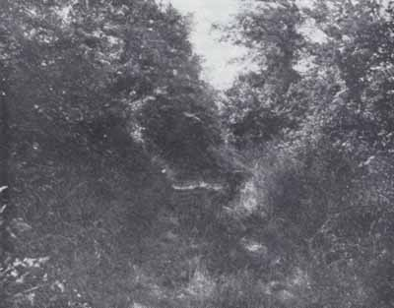
HEDGEROWS such as this one enabled Rangers left behind after the night attack to hide until relieving forces reached the area on D+2. This photo, taken June 1945, shows the lane that leaves highway just east of Au Guay and runs toward the cliffs.
Colonel Rudder was told that the rest of the force had been destroyed. "Neutralized" would have been a more exact word. All Company E Rangers from Main's fox hole to the angle had been killed or captured, and a few men of D near the corner had been included in the disaster. But from about 30 yards north of the angle and on to the highway, the rest of D's contingent (some dozen men) were still in their original positions, scattered along 250 yards of hedgerow. They had no notice of a withdrawal. When they realized it was under way, they had no chance to move, with Germans in the fields to their rear and flanks. Daylight was near, and the 12 men stayed in the deep drainage ditch, overhung with the heavy vegetation of the hedgerow. They had delivered no fire during the attacks and could only hope the Germans had not spotted their positions.
On the east-west hedgerow, between the breakthrough area and the CP, three more Rangers had been left behind in the confusion of withdrawal. Main was one. Another was Tech. 5 Earl Theobold, who had been in the field guarding prisoners. During the final attack he came over to the hedgerow near Main "to help out." He could find no Rangers, and soon heard German voices near the CP, so he hid in the ditch. Pfc. Loring L. Wadsworth, in the same sector and about 75 yards from Main, had missed the word of withdrawal. When he finally called to his nearest neighbor, who had been only a few yards off, Wadsworth got no answer, and stayed put under a tangle of briars.
Both Theobold and Wadsworth were caught during the next two days. Wadsworth was spotted early in the morning. Theobold lay quiet for most of the day, then thought he was seen by a passing German and bolted out toward the highway, without drawing fire. He hid again in a ditch near the highway, for the night. On the morning of D+2 firing came close to his hideout along the road. It was the 116th Infantry, attacking to relieve the Point, but Theobold could not know that. Leaving the highway and cutting south, he was captured by a machine-gun post near the creek. Main spent D+1 watching German patrols go by, and a machine gun being set up in the field near his hedgerow. That night he crawled out, threw a grenade in the general direction of the machine gun, and "lit out for the Point" without drawing enemy fire.
The Company D men lay hidden all the next day under their hedgerow. No enemy search of the area was made, and they saw only a few Germans during the period. Their main cause of worry was fire from naval guns, supporting the beleaguered Point; from time to time, friendly shells came close enough to "bounce the men around" in their holes, but there were no losses. Late in the day their hopes were raised and then dashed. Four Sherman tanks rolled down the highway toward Grandcamp within sight of the Rangers. But no infantry followed, and in a short while the tanks came back and went off eastward. Germans reappeared in the field at dusk and set up machine-gun positions; the isolated Ranger group settled in for another night. They were freed next morning by the 116th Infantry.
On D+1 Colonel Rudder's force at Pointe du Hoc consisted of about 90 men able to bear arms. Restricted to a few acres, including only a part of the fortified area, they expected to be the target for heavy concentrations of artillery, and for assault by enemy ground forces. With the support of strong naval fire the Rangers held out during the day, and that afternoon their situation was improved by the landing of a craft with food, ammunition, and a platoon of reinforcements. By night they were in touch with patrols of a relief force that had reached St-Pierre-du-Mont, only 1,000 yards away. The relief of the Point came next morning, on D+2.¹

The Relief Effort: 7 June 1944

Excerpt from CMH PUB 100-11. Omaha Beachhead, 1-63. Page 125-127

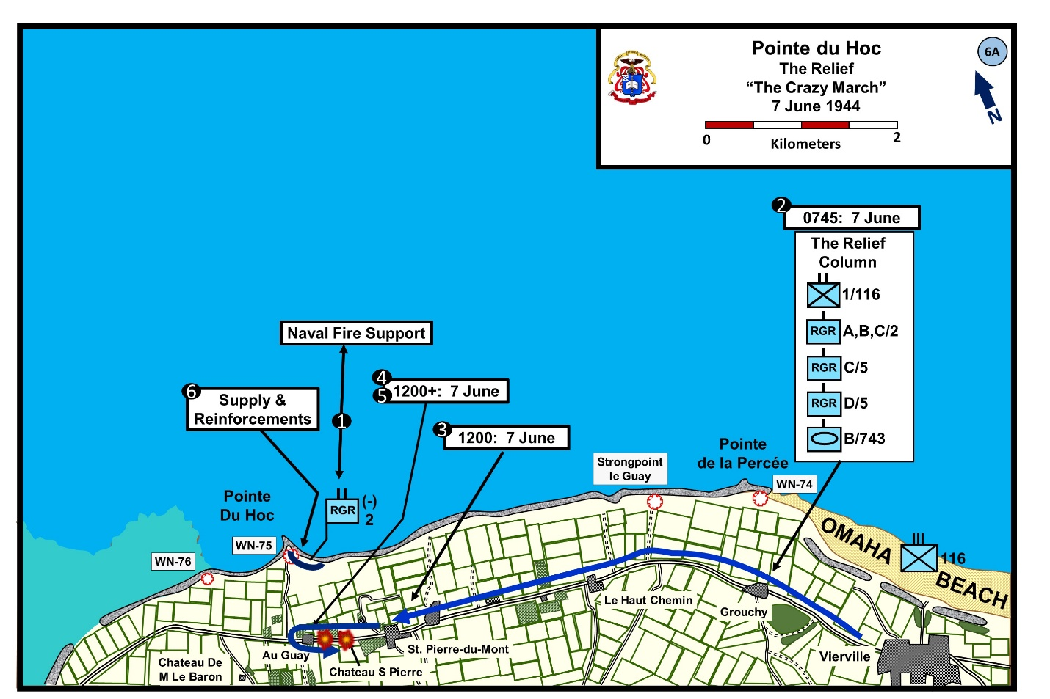
The force which started west on the Grandcamp road to relieve Pointe du Hoe was stopped just short of its goal on 7 June. As a result of the enemy's early morning thrust at Vierville, four companies of the 5th Ranger Battalion had been left to guard the village, where they spent the day in mopping-up operations. The remainder of the relief force, amounting to about 500 men, began its march about 0800, headed by Companies A, B, and C of the 2d Rangers moving in a double file on each side of the highway. Ten tanks of Company B, 743d Tank Battalion, followed close behind the point, ready to move up or down the column as needed. Many small enemy positions were passed, some almost at the edge of the road, but they were not allowed to hold up the advance. The tanks sprayed them with heavy fire to cover the infantry, which was never forced to deploy and did not stop to clean up bypassed enemy groups. Good progress was made with this system, and at 1100 the column reached St-Pierre-du-Mont, only a thousand yards from Pointe du Hoc.
Conditions at the Point had become more critical overnight. When the platoon of Company A, 5th Rangers, reached the Point at dusk of D Day, they believed the rest of the 5th Rangers were just behind.
At morning of 7 June, the force on the Point numbered 90 to 100 men available for action, many of them with light wounds. They had no food, their ammunition supply was short, they had brought no machine guns in their landings, and only two mortars were left. They were pinned on a strip about 200 yards deep and 500 yards wide, including in it the wrecked enemy fortifications. Snipers were still appearing inside this area, and enemy movements indicating preparation for attack could be seen close by. Naval fire support, rendered at different times by the destroyers Barton, Thompson, Harding, and O'Brien, was the Rangers' main defense and was called on heavily to shell suspected assembly areas. With this aid and maximum use of their two mortars which fired 300 rounds during the day, enemy attack was held off.
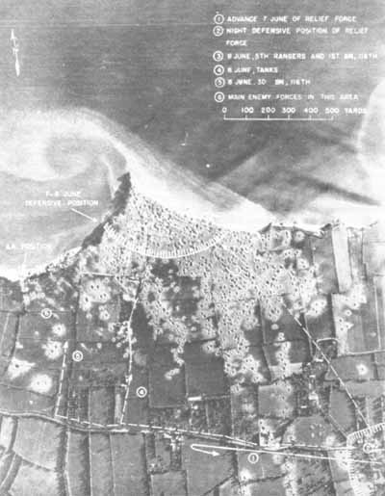
The Relief of Pointe du Hoe, 7-8 June
Their communications still limited to occasional contact with passing naval vessels, the Rangers on the Point were unaware through most of the day that a relief force was very near and was battling to reach them. After reaching St-Pierre-du-Mont before noon, the relief column planned to push along the coastal highway to the junction of the exit road from Pointe du Hoe. Company A of the 2d Rangers, forming the column's point, got to a hamlet within 200 yards of the exit road, when heavy interdictory fire from medium howitzers fell on the highway behind them, forcing the tanks to withdraw. Reforming at St-Pierre, the column tried again. This time the tanks got past the exit road, but the 1st Battalion of the 116th was caught by well-directed artillery fire which blanketed a quarter-mile stretch of the highway, and lost 30 or 40 men. This forced another withdrawal. The 58th Armored Field Artillery Battalion and naval guns endeavored to locate the enemy batteries, somewhere to the southwest. Efforts were made to organize a third attack, again along the highway, but the afternoon ended with the relieving force still in St-Pierre-du-Mont. Its advance had undoubtedly taken some of the pressure off the Point, and patrols made contact that night with the beleaguered force. During the afternoon, two LCVP's landed at the Point with food, water, ammunition, and about 30 reinforcements picked up at Omaha Beach. The worst of the situation was over.
The Relief Effort 8 June 1944

CMH PUB 7-4. Cross-Channel Attack, 350, and other sources as noted.
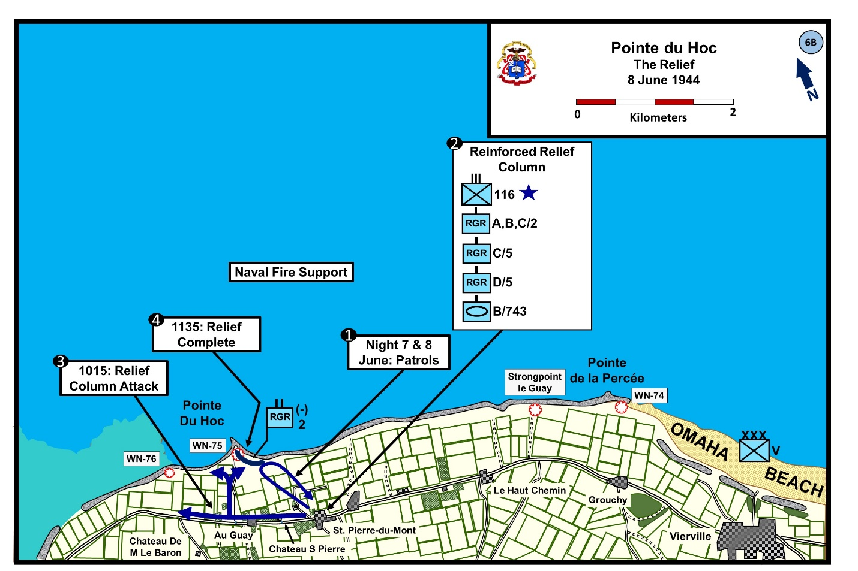
Late night 7 to 8 June, Ranger patrols from St. Pierre-du-Mont made contact with Rudders beleaguered force. However, this information was not fully disseminated to the entire relief force that Rudder’s Rangers still held the Pointe.

On the morning of 8th June, the other BNs of the 116th RCT joined the relief force and the push to expand the beachhead. About 1015, the relief force resumed its advance. Again there was significant coordination problems between the two ground forces and the Navy that unfortunately resulted in at least four friendly fire casualties among Rudder’s men. Naval observation planes had relayed to the BS Texas that the Rangers at the Pointe were being attacked by tanks. The tanks belong to the relief force which were attacking north along the access road. One group from the relief forces swung NW toward the enemy western flak bunker and another swung NE toward the center of Rudder’s defensive line.

Rudder’s men were using a significant number of German weapons. The distinctive sound of the German weapons caused the relief force to fire upon them. The Navy asked Rudder if he needed support. Rudder replied “No” and the Navy asked “Are you being hit by friendly fire,” and Rudder replied “Yes.” The Navy acknowledge and stood by for further instructions. About 1135, Rudder was able to call-off the U.S tanks and infantry attacking his line and the 116th RCT notified division that they had relieved Rudder’s Rangers at the Pointe. The Battle for Pointe Du Hoc was over.
PREPARING TO LEAVE THE POINT ON D+2. The relief accomplished, 2d Rangers Joined in drive toward Grandcamp. Col. Rudder (arrow) had been wounded 3 times, but accompanied his force.
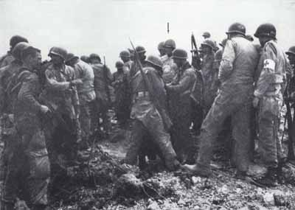
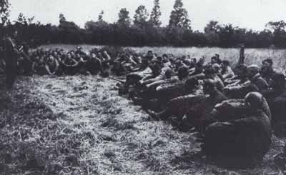
MEN OF 2D AND 5TH RANGERS at a religious service held in a Norman hedgerow field by the chaplain of Ranger Force.

Appendix A: Assignment #1: The Germans at Pointe Du Hoc. From War Department TM-E30-451 Handbook on German Military Forces
https://www.ibiblio.org/hyperwar/Germany/HB/HB-2.html other sources as listed.

The strongpoint at Pointe du Hoc fell under the defensive sector of the 726th Infantry Regiment which was responsible for a 10K portion of the beach with the Pointe roughly in the center. The 726th parent division was the 716TH STATIC IN Division, however the regt. had been attached to the 352d IN Div. As a STATIC unit it was configured to occupy fortifications. The regt. contained a high percentage of non-German troops, and was regarded as of limited fighting value. The Germans garrisoned the Pointe with the 2d Battery of Army Coastal Artillery Regiment 1260 (2/HKAA.1260), consisting of 85 artillerymen. There were also an estimated 125 infantrymen from 9/III/726 Grenadiers (GR) defending the position. The III BN designation is confusing. The 726th order of battle only shows two battalions. However, the 439th Ost Battalion was attached to the 726th as its III Battalion and its companies numbered 9, 10, 11, and 12. The Germans formed the Ost (Eastern)-Battalions from various nationalities, raised mostly amongst prisoners of war captured in Eastern Europe or easterners opposed to Soviet rule. These battalion-sized units were integrated individually into German combat formations.

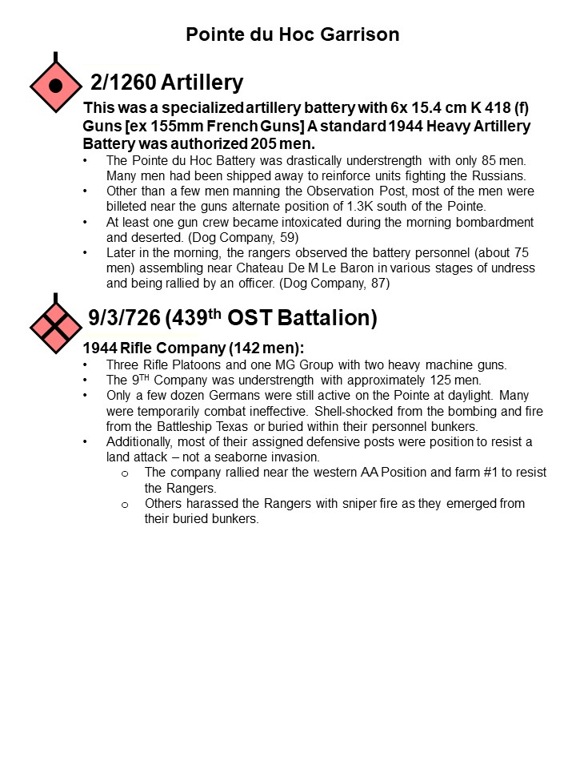

The Initial German Counterattack was not a major effort. The 352d IN DIV was aware of the attack at the Pointe. However, due to the troubling events at Omaha the news was not particularly alarming. Only the assault platoon of 726th Grenadiers was sent to counterattack what they believed to be a commando raid. The record is not definitive, but the assault platoon may have been the 726th Grenadier’s Combat Engineer Platoon. Early afternoon, the German platoon advanced out of St. Pierri-du-Mont against the Ranger’s eastern flank. The attack was supported by artillery. It was an hour long fight, with the Germans setting up a machine gun in a hedgerow south of the Rangers’ position. The Rangers beat back the German with mostly with small arms.

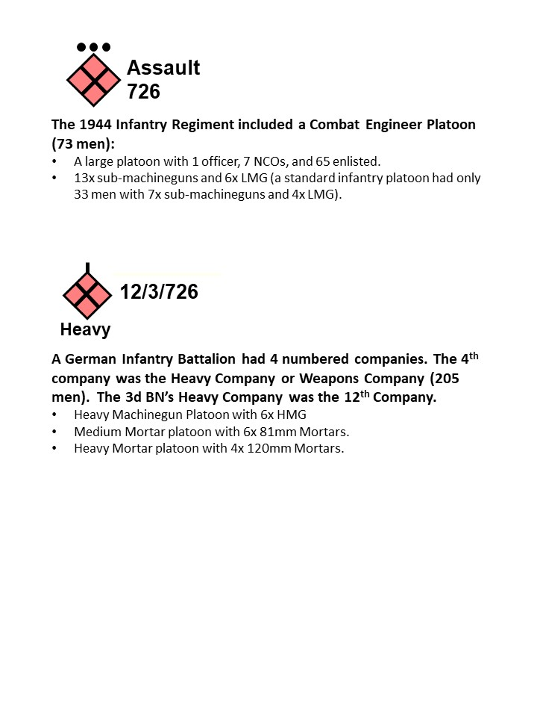

In the late afternoon, the Germans made a more serious attack against the Rangers. The III/GR. 726 attacked with its 12th Company. The 12th Company is the battalion’s heavy weapons company. However, it would not be unusual for the heavy machinegun platoon to deploy its three heavy machine guns section as infantry squads with two LMGs each. Additionally, some of the mortar squads could fight as infantry. At 1600, the company attacked. One group of Germans (about platoon strength) approached gun pit #3 along the cliffs from the flak bunker and was dispersed by a well-aimed BAR fire and mortar fire. Another group (also platoon strength) moved north along the exit road and closed to about 50M from gun pit #1. Again the Rangers defeated the attack. The 12th Company tried to regroup, but the Ranger’s mortar fire and naval support stalled their efforts and the 12/III/GR. 726 was content to contain the Rangers through the remainder of the day. III/GR. 726 companies numbered 9, 10. 11, 12.

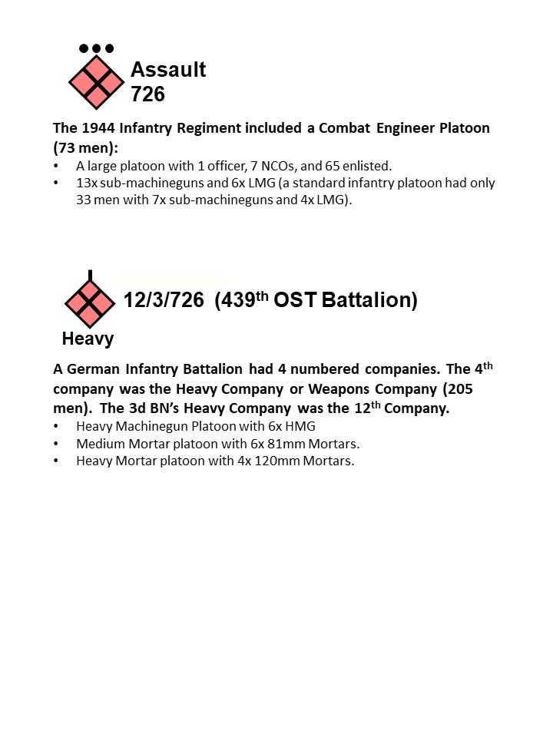

Elements of the I/GR. 914/352 IN Div operated against the Rangers on the coastal highway. The 352nd Infantry Division was a 1944-type division. It was a new division (formed March 44), but was almost at full strength and contained a significant number of combat veterans. The 914 Grenadier Regiment was one its three regiments. The regiment had two infantry battalions each with 4 companies. The first three companies were infantry companies and the 4th company was referred to as the Heavy Company (Weapons Company).

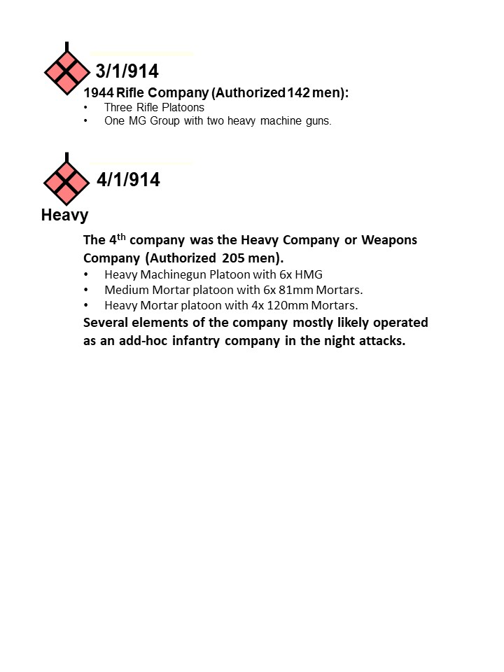

About 2330 – 30mins after sunset, elements of the I/GR. 914 (3d and 4th Company) initiated its attack against the Rangers. The Germans were able to infiltrate through the orchard almost to the edge of the Ranger defensive line near “the angle” without being discovered. At the edge of the orchards, the German officers opened the assault with whistles and shouts. The fight was a confused and short-range skirmish that lasted only a few minutes. The Germans backed off after a significant powder explosion occurred at the abandoned battery positions that disrupted their assault. Nevertheless, the Germans had identified the main Ranger defensive line and inflicted casualties among the E Co. Rangers holding the “angle.”

At 0100, I/GR. 914 commenced the second attack. Again, the Germans were able to close to within 50 meters of the Ranger line before they were detected. Once more, shouts and whistles initiated the assault. Additionally, the German assault included large amounts of tracer fire and inaccurate mortar fire. The assault hit E Co., slightly to the east of the first attack and succeeded in pushing into the vicinity of “the angle.” Most of the Rangers at the Angle retreated to the north.

At 0300hrs, the I/GR. 914 executed a third attack to exploit the earlier successes. It followed the same pattern of whistles and shouts, tracers and mortar fire. The Germans broke through the E Co. positions to the east of the “angle,” and soon after that poured enfilade fire along the inside of the hedgerow line. About 20 Rangers near the German breakthrough surrendered. The inherent confusion associated with a night attack resulted in the Germans not exploiting their success and instead holding at the coastal highway instead of continuing to advance toward the Pointe.

Appendix B: Notes on LTC James Rudder and the Ranger Task Organization

Biographies of LTC Rudder are readily available with an internet search. Highly recommend - The First Night on Pointe du Hoc: An Excerpt from Thomas M. Hatfield's Rudder: From Leader to Legend at https://www.humanitiestexas.org/news/articles/first-night

The plan called for LTC James Rudder to command the Ranger Group from the Command Ship USS ANCON. The ANCON was the CP for: Admiral Hall (Commander of the O Force) General Gerow (5th Corps), General Huebner (1st Infantry Division) and General Hoge (1st Special Engineer Brigade). On the night of 5 June, Rudder relieved Major Cleveland Lytle, the commander of Force A, because of a drunken brawl and his lack of faith in the feasibility of the mission. Then Rudder took direct command of Force A. Both LTG Bradley (US 1st Army) and LTG Huebner reluctantly approved the last minute change. There was concern that no one was now overlooking the activities of the Ranger Group.

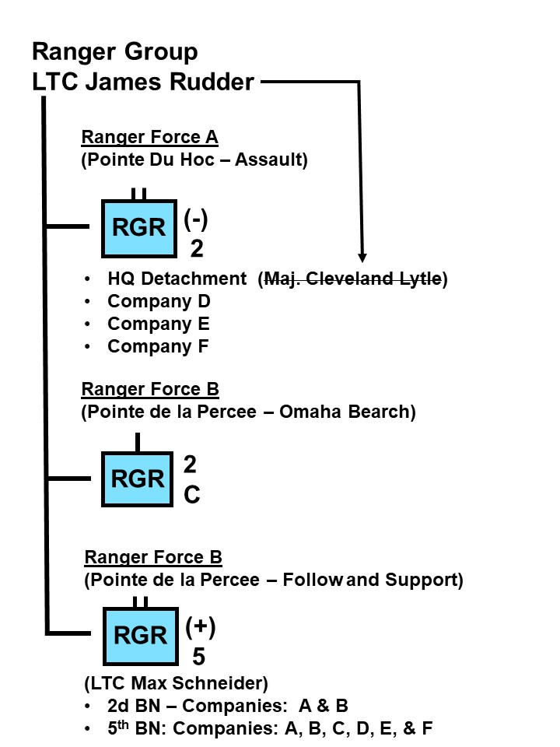
Ranger Force A: Companies D, E, and F, 2d Ranger Bn were designated to make the assault. The plan called for D Company to attack from the west side of the point and seize Gun Positions (GP) 4, 5, & 6. E & F from the east side. With E Company to seize the Observation Point and GP #3 and Company F had GPs 1 & 2.

Each Ranger company, consisting of 68 men (half the size of a normal rifle company), had specific assignments. The company’s only heavy weapons were four BARs and two 60mm mortars per company. After the attack all units were to assemble in the middle and move inland to cut the coastal highway. Altogether, the Ranger force (with attachments) for the Pointe du Hoc mission totaled 225 men.

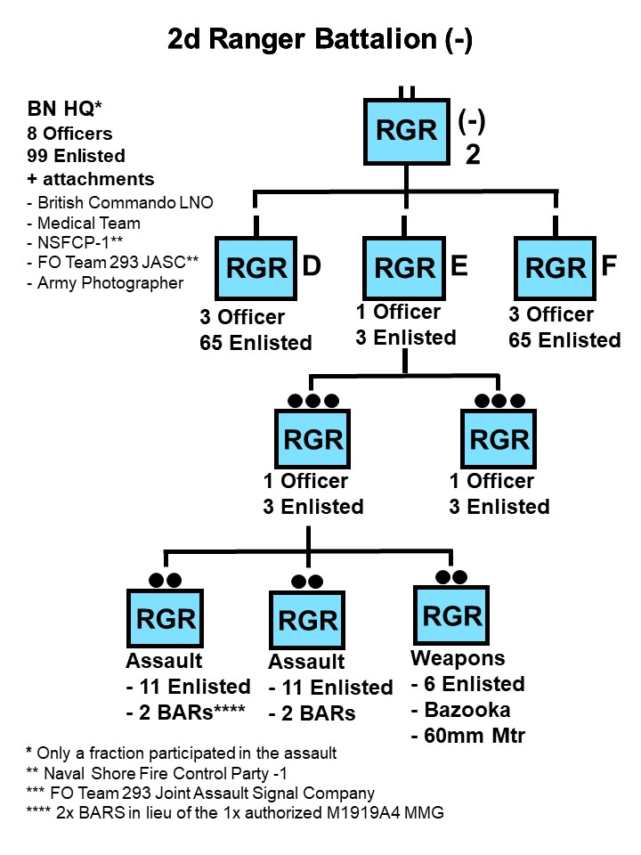
Each company was assigned three or four LCA (Landing Craft Assault) for the mission. Additional LCA carried supplies and there were four DUKWs mounting fire truck style ladders.

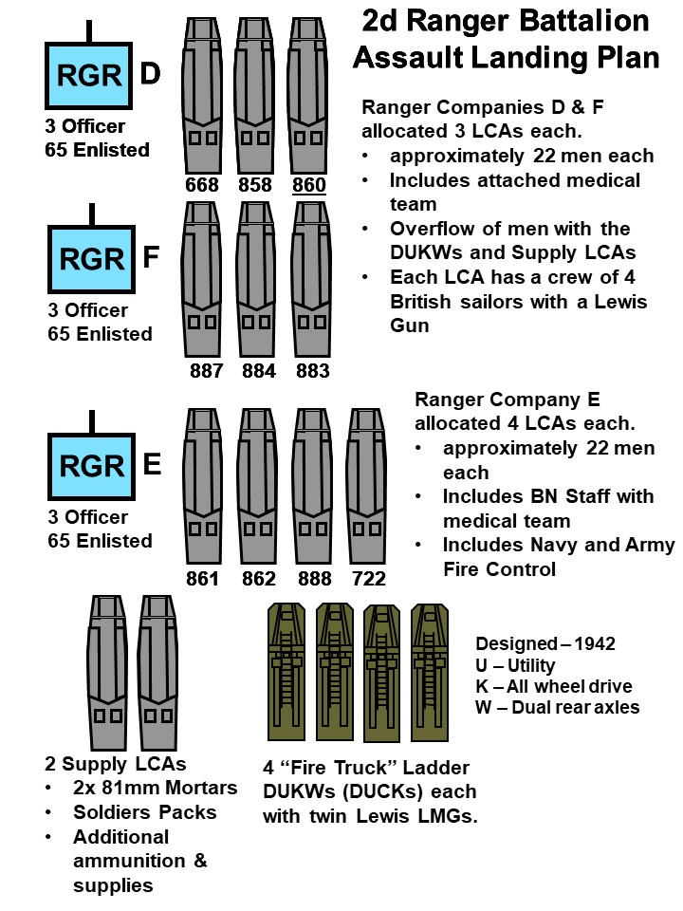

Appendix C: Ranger Organization in the Strongpoint Area

At 0745 – 6 June, LTC Rudder directed CPT Otto Masny (F Co.) to take charge of securing the battery area. Masny immediately sent word for the Rangers that had not yet moved to the coastal highway to hold at the Pointe. Mansy had most of his company plus elements of both E and D Companies. Early morning of the 7th, the survivors of the coast highway group joined with the Masny’s Rangers to secure the Pointe.

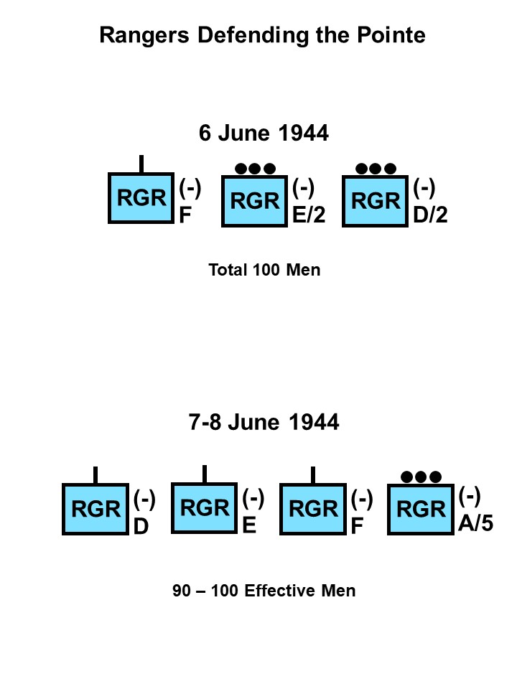

Appendix D: Ranger Organization in along the Coastal Highway.

On the morning of the 6th about 47 Rangers coalesced on the coastal highway to execute their secondary mission of protecting the west flank of the Omaha Beach Landings by blocking the coastal highway. By that afternoon their numbers increased to approximately 61 Rangers. That evening 25 men from A Company, 5th Rangers joined them.

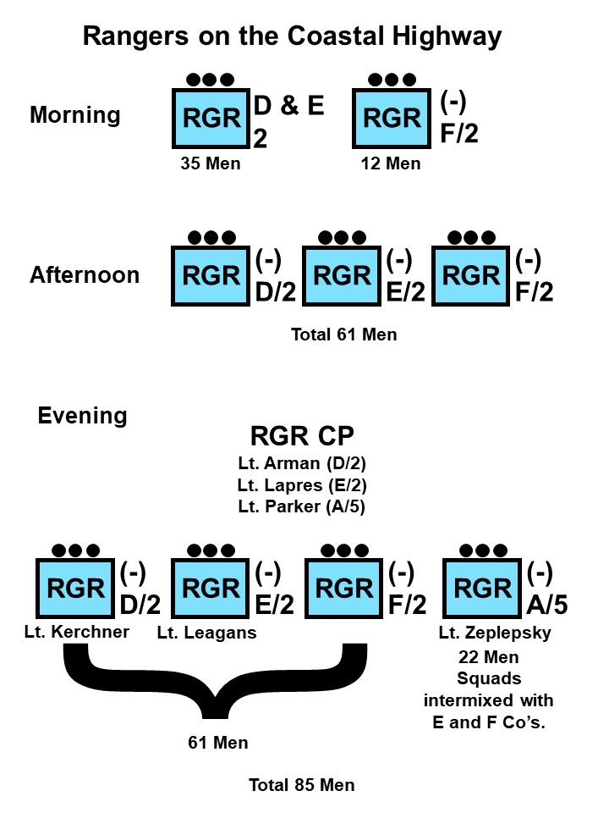

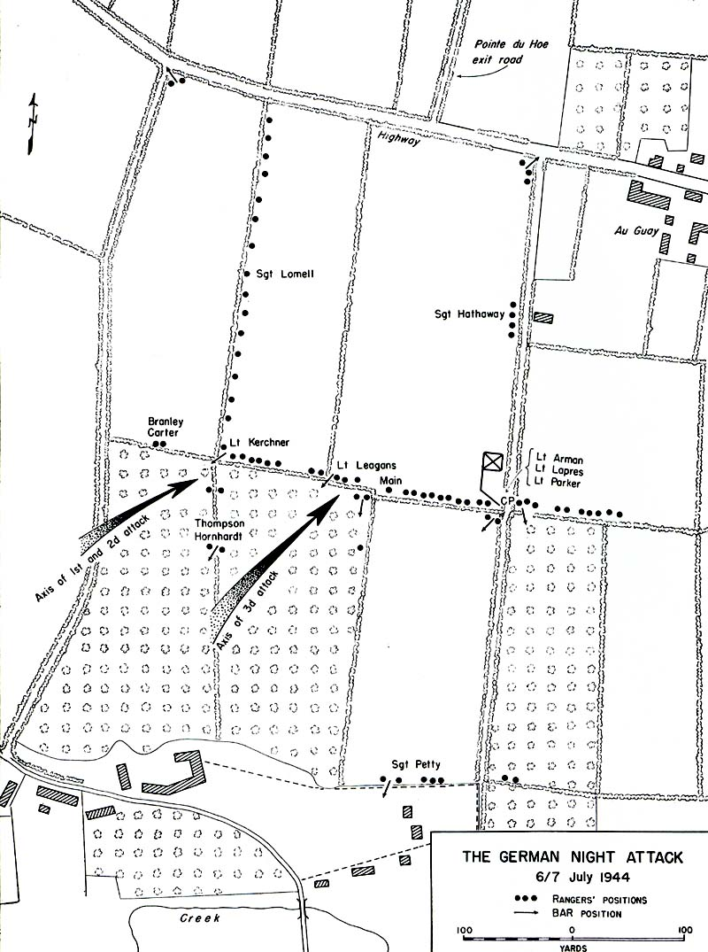
Map should say 6/7 June 1944.

Appendix E: Naval Support and the USMC at Pointe du Hoc.

Naval support played a key role in the Rangers successful assault onto Pointe du Hoc and their ability to hold the objective until relieved on the morning of 8 June. Several different naval vessels supported the Rangers. These include LCAs, Motor Launches, Destroyers, Cruisers, and Battleships.
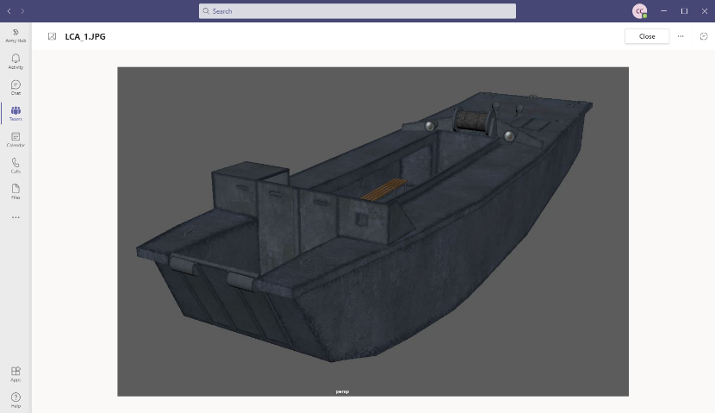
LCA (Landing Craft Assault): British LCAs, operated by British crew of four sailors, were used in training and in the actual operation. A total of twelve craft were allocated for the mission (Approximate load capacity of 22 troops per craft). There were ten troop carrying LCAs and two LCAs for supplies (See Appendix B). LCAs were similar to the American LCVP (Landing Craft Vehicle Personnel / Higgins Boat), except that it had some armor protection, which made it slower and heavier. As a result, it rode lower in the water than its American counterparts. The LCA were also armed with a Lewis LMG. It was designed to push the bow up onto the beach and the small ramp provided a dry landing for the assault troops. The US Higgins boat had a larger ramp and normally dropped the ramp several feet from shore for a wet landing. Several LCA were damaged in the assault and their British crews joined the Rangers at the Pointe with their LMGs.
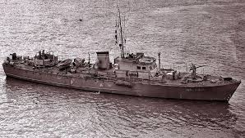
Royal Navy Motor Launch (ML): The RN Motor Launch was made of wood, 34M long and weighed about 80 tons. It was armed with 3-pound Quick Fire gun forward (fired a 3 pound projectile), a 20mm AA gun at the stern, and two machineguns amidships. Lieutenant Colin Beever’s (Royal Navy Volunteer Reserve) ML 304 was responsible for leading the Force A flotilla to the Pointe. Unfortunately, the navigation system on ML 304 failed. This combined with the rough seas, strong current, and darkness resulted in ML 304 leading the Rangers toward Pointe de la Percée, about 5k east of their objective. At 0630, daylight revealed the shoreline about 1000M distance and LTC Rudder realized the navigation error and directed his LCA to turn hard to west and signaled the other LCAs to follow. At first the British crews of the LCAs were reluctant to change course – their orders were to follow ML 304. Getting the Army ashore was a Navy responsibility and no Army officer had authority to overrule the commander of ML 304. Lt. Beever quickly recognized his navigational error and resumed the lead toward Pointe du Hoc. The change in course required the flotilla to hug the coast line back to Pointe Du Hoc against a gauntlet of fire. The commander of the destroyer HMS Talybont remembered, “Their course… along the shore to Pte. du Hoc was suicidal.” Lt. Beever, despite his navigation challenges, was no coward and took his wooden ML close inshore during the cliff assault. His crew fired 20 rounds from his small main gun and over 1,000 20mm rounds.
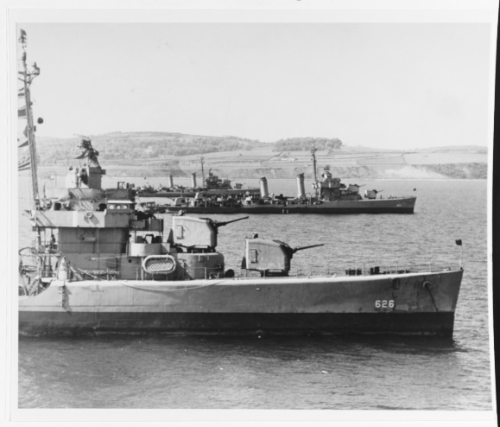
Destroyers: Several destroyers supported the Rangers at Pointe du Hoc. Most prominent in the writings are the USS Saterlee and the HMS Talybont of Destroyer Division 36. The Saterlee displaced 1,630 tons and was 106m long. It was armed with 4x 5” guns, 4x dual 40mm AA guns, and 7x 20mm guns. Ironically its radio call sign was “Wimpy.” The HMS Talybont was smaller at only 1,050 tons and 80m long. It was armed with 4x 4” guns, 5x QF 2 pdr guns (40mm). Destroyer Division 36 brought a huge amount of firepower to the fight and were in direct support to the Rangers throughout the day.

One of the best examples is when Shore Fire-control Party (NSFCP) directed the USS Satterlee’s fire unto the MG position threatening the flank of the Ranger landing and silenced it. During the engagement, the destroyer closed to within 180M of the shore and literally blew the MG position off the side of the cliff. The Satterlee, in its report, placed special emphasis on the excellence of its communication with the shore party, and the effectiveness of the system of fire control. The NSFCP had been on board the destroyer and worked with it in several drills and an exercise, before D Day. The Rangers also used a blinker light to communicate with the Destroyers using Morse Code. By 1723 the Satterlee had expended 70 percent (the prescribed maximum) of her ammunition, having fired 164 salvos, plus six minutes of fire for effect, in support of the Rangers since H Hour. The USS Baton and USS Thompson moved in near the Point to relieve the Satterlee and Talybont.

During daylight hours (0600 to 2200), supporting fire from the destroyers off shore was critical to the Ranger defense at both the strongpoint area and along the coastal highway. On the 6th, the Rangers at the strongpoint used naval gunfire against two German counterattacks. The Rangers on the coastal highway had no radio to coordinate the fire with the Navy. They used the naval gunfire against observed concentrations of German troops. They had to send a patrol back to the Ranger CP at the cliffs with the fire support request – about 1000 meters to the rear. A follow-on patrol had to then relay the fire corrections. At 1950hrs, the USS Thompson fired on concentration of troops at the Chateau de M. la Baron. The Thompson’s first salvo hit the chateau and forced the German company concentrating there to wait till dark to stage their attack. Shortly before nightfall (2200), the Rangers on the coastal highway coordinated another naval strike against seven targets.

There were some disappointments with the Naval Support. LTC Rudder, using the signal lamp, asked for the Navy to evacuate his wounded. The Navy did try to send a whaleboat towing rubber rafts to the Pointe to evacuate the seriously wounded but it was driven back by German MG fire with one Navy crewman wounded. The Navy was also unable to effectively engaged the German western AA position that harassed the Rangers throughout the 6th and 7th. The AA postion was just back from the cliff edge and not visible from the sea and the fire control party was never able to successfully direct indirect fire onto the position. Additionally, several short rounds caused some casualties among the Rangers.

The commander of Destroyer Division 36 put in his action report, “The gallant fight of our Rangers against tremendous odds and difficulties was an inspiration to all naval personnel fortunate enough to witness this phase of the battle. The Rangers were magnificent.”

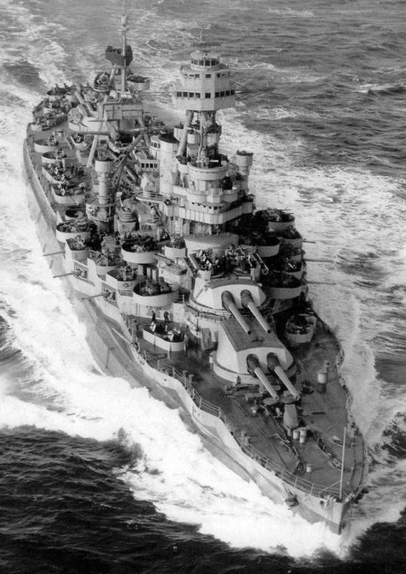
Battleships and Cruisers: Several larger ships provided support to the Rangers. Two of the most notable are the USS Texas and the HMS Glasgow. The Texas (BB-35) was commissioned in 1914 and was one of the few ships to fight in both WWI and WWII. Despite its age, the 27,000 ton “Mighty T” brought 10x 14” guns to the fight. Each firing a 1,400lb shells out to a range of 13 miles (21K). Texas was designated Bombardment Force Flagship for Omaha Beach. From 0550 to 0630 the battleship USS Texas bombarded the Pointe with 250x 14-inch shells. The bombardment was directed by spotter planes and it was both accurate and devastating. The plan called for the Rangers to assault the cliffs at 0630+ minutes after the bombardment lifted. However, the Rangers were 30 minutes late. Nevertheless, the German garrison was both shell-shocked and buried inside their bunkers. It is estimated that only a few dozen Germans actually opposed the landing.

The TEXAS’s priority of support was to the Army’s V Corps on Omaha Beach. Nevertheless the TEXAS’s command team appears to have had good situational awareness on the Rangers at Pointe du Hoc. After the Ranger’s sent the message “Located Pointe du Hoc-mission accomplished-need ammunition and reinforcement-many casualties” to the Satterlee. The commander of the TEXAS considered sending his USMC detachment (86 men) to reinforce the Rangers. However, he was told to stand down and specifically told that the marines could not ride shotgun on the LVCPs that would attempt to take supplies to the Pointe.

On 7 June, an Army officer and former Ranger serving on Admiral Hall’s staff organized a relief effort for the Rangers. He loaded two LCVP's with food, water, ammunition, and about 30 reinforcements picked up at Omaha Beach. (The reinforcements were a collection of 29th Infantry soldiers and 5th Rangers that had been separated from their unit and milling about on the beach and commandeered by the staff officer).

One of the most significant big guns mishaps at occurred with the HMS Glasgow. The Glasgow was a British Light Cruiser armed with 12x 6” guns. It was primarily providing support to units on Omaha. However on the morning of 6th June it responded to a call for fire at the Pointe.
One of LTC Rudder’s signalmen had repaired a German radio in one of German bunkers. Rudder and part of his command group went to the bunker to use the radio. Unfortunately a shell from the HMS Glasgow fell short and hit the bunker. The blast killed the Army Artillery Observer (Captain Harwood) and Rudder’s radio man. It also wounded the Naval Fire observer (Lt Norton). Rudder received splinters of concrete into his right arm.

On the 7th and 8th of June the Naval forces had much better awareness of the situation at the Pointe than the 116th Infantry advancing west from Omaha Beach. Throughout the relief force’s advance, many of their calls for fire were denied by the Navy. The relief force believed Rudder’s force had been destroyed. However, the Navy was well aware that Rudder was continuing to fight and would not endanger the Rangers at the Pointe. However, the information that the Rudder’s men were still fighting never made its way to the relief force. On the 8th, the relief force resumed its advance to the west. Again there was significant coordination problems between the ground forces and the Navy. Naval observation planes relayed to the Texas that the Rangers at the Pointe were being attacked by tanks. Rudder’s Rangers were using a significant number of German weapons. The distinctive sound of the German weapons caused the relief force to fire upon them. The Navy asked Rudder if he needed support. Rudder replied “No” and the Navy asked “Are you being hit by friendly fire,” and Rudder replied “Yes.” The Navy acknowledge and stood by for further instructions. About 1135, Rudder was able to call-off the U.S tanks and infantry attacking his line and the 116th RCT notified division that they had relieved Rudder’s Rangers at the Pointe. The Battle for Pointe Du Hoc was over.

The Ranger companies averaged 65 men.
The LCAs had been designed with shallow draft and for relatively slow speeds; under D-Day conditions they proved less seaworthy than the LCVPs, although their draft permitted them to make drier landing.
If, as French civilians later reported, many such shells had been hung, they were probably neutralized by naval fire. No other Ranger party saw them. They may have been planned for dropping to the beach rather than for explosion at the cliff edge.
The photograph on page 14, taken a year later, shows the cliff at the point where 861's men climbed. Two ropes, one of them a ladder type, are still in place. This suggests that later climbers brought up a rope ladder to supplement the first rope, but the point cannot be settled by available evidence.
On the afternoon of D+1 the nest was finally cleaned out. Two satchel charges of C-2 were thrown in the entrance, and Aguzzi, still on guard, figured the enemy must be wiped out. But eight unwounded Germans swarmed out with their hands up, and only one body was found inside. The Rangers were never sure how many enemy had been in the post, for the OP, like most positions in the fortified area, was connected with underground passages which the Rangers had neither numbers nor time to investigate fully. These underground routes, connecting shelters with each other and with a maze of ruined trenches, probably contributed to troubles on the Point during D Day.
The Rangers' term for the paved highway.
The Satterlee, in its report, placed special emphasis on the excellence of its communication with the shore party, and the effectiveness of the system of fire control. The NSFCP had been on board the destroyer and worked with it in several drills and an exercise, before D Day.
From the positions indicated, it is probable this group came from the antiaircraft position to the west, rather than up the road. A wounded Ranger, left behind for dead after Masny's abortive morning attack on the antiaircraft position, saw Germans pass by from the west for an attack that (as he later reported) was stopped by mortar fire.
Zaloga, Steven. Rangers Lead the Way, 5. The 4th Company is the battalion’s heavy weapons company. See Appendix A for further detail.
Burnett escaped a few days later by killing a guard, was helped by the French Underground, and succeeded in getting back to the Allied lines after they reached Rouen in August.
Zaloga, Steven. Rangers Lead the Way, 57.
Badsey, Stephen. Battle Zone Normandy, Omaha Beach, 34-35.
Zaloga, Steven. D-Day 1944, 79
Zaloga, Steven. Rangers Lead the Way, 33.
Gunfire Bombardment Support Force C provided fire support at Omaha Beach. It consisted of the battleships USS Texas and Arkansas, the French cruisers Montcalm and Georges Leygues, the British cruiser HMS Glasgown, nine US destroyers and three British destroyers. It appears that the USS Satterlee and HMS Tallybont spent most of the 6th near Pointe du Hoc.
Black. The Battalion, 80-81.
COMDESDIV 36 Action Report. https://www.history.navy.mil/research/library/online-reading-room/title-list-alphabetically/d/destroyers-at-normandy.html
Gawne, Jonathan. Spearheading D-Day, 220.
CMH Pub 100-11, Omaha Beachhead, 126.
Zaloga, Steven. Rangers Lead the Way, 42-43; and Black, Robert. The Battalion, 134.

